Analysing Data

A practical primer using EpiInfo

Mark Myatt, Sue Ritter,
Esther Hudes, Deborah Bain & Alison Graves

First published in 1996 by Brixton Books, Station Building, Llanidloes, Powys SY18 6EB

This edition published 2000 for use solely by the Center for AIDS Prevention Studies, University of California, San Francisco.

Copyright © 2000 Mark Myatt, Sue Ritter, Esther Hudes, Deborah Bain and Alison Graves

All rights reserved. No part of this publication may be reproduced, stored in a retrieval system or transmitted in any form by any means, without prior permission of the publisher, nor otherwise circulated in any form of binding or cover other than that in which it was originally published and without a similar condition being imposed on the subsequent purchaser.

A CIP catalogue record for this book is available from the British Library

ISBN 1-873937-46-6

Note: The previous edition of this text has been modified by Esther Hudes, Deborah Bain, and Alison Graves of the Center for AIDS Prevention Studies, UCSF, for use by the International Visiting Scientists Program. The original data set used for this publication, SSSW.REC, was replaced by a data set compiled from data collected during the San Francisco Men’s Health Study, SFMHSHIV.REC. The text has also been altered so that it reflects EpiInfo version 6.0. Details of the SFMHS is given on page 9 of this publication.

‘There is one outstandingly important fact regarding Spaceship Earth, and that is that no instruction book came with it.’

R. Buckminster Fuller, Operating Manual for Spaceship Earth

Contents
Introduction | 7
Qualitative/categorical and quantitative/numerical variables | 11
Files, cases, and variables | 12
Retrieving and examining a dataset in ANALYSYS | 13
Working with subsets of data | 15
Producing charts | 18
Chart types and their uses | 20
Summarising distributions  Frequency distributions  Qualitative/categorical variables  Quantitative/numerical variables  The seven figure summary  How the standard deviation measures variability  Calculating the standard deviation - worked example  Standard deviation and degrees of freedom  Problems with the mean and standard deviation  Calculating summary measures in ANALYSIS  Summarising distributions with charts | 22  24  24  26  27  28  29  30  31  32
Creating and recoding variables | 34
Two-by-two tables  Naming of parts  Crude risk  Exposure specific risk  Relative risk  Odds ratio  Measures of risk (summary)  Confidence intervals  Testing a hypothesis about association  Chi-square, degrees of freedom, and p-values  Confidence intervals and significance tests  An example of ANALYSIS output | 38  39  40  41  42  43  45  46  48  50  51
Contingency tables | 52
Tables with subsets of data | 55
Differences in means  Categorical and continuous data  Analysis of variance  A worked example of ANOVA calculations  An example of ANALYSIS output  What ANOVA assumes about your data  Testing the ANOVA assumptions  When ANOVA is unsuitable  Transforming the data  Checking data for skew and unequal variance  Applying a logarithmic transformation  The antilogarithm of the mean of the logarithms (geometric mean)  Difficult distributions  Another problem with ANOVA (sample size and group sizes)  Non-parametric statistics  Differences in medians (Wilcoxon Rank-Sum Test)  Non-parametric tests in ANALYSIS | 57  58  59  60  62  63  65  66  67  68  69  70  71  71  72  73
Two continuous variables  Correlation and regression analysis  Using scatter plots to examine associations  Assessing the strength of an association  The correlation coefficient and non-linear associations  Transformation and non-linear associations  Scatter plots and correlation coefficients  Interpreting the correlation coefficient  The regression line  Linear regression in ANALYSIS  What the regression line does not explain | 75  76  77  78  79  81  82  83  85  86
Solution to practical exercises | 90
Statistical tables | 102

Introduction

How to use this book

This is a self-contained course in the basic techniques of statistics and data analysis. Whilst much theoretical material is introduced, extensive use is made of computer based practical exercises. In this way you will learn the basic techniques of statistics and data analysis whilst actually doing statistics and data analysis yourself. All techniques are introduced in the context of analysing a real-world study of HIV infection among men in San Francisco. This highly practical bias means that you should be seated at your personal computer as you work through this book.

Typographical Conventions

Several typefaces are used throughout this book. The following table illustrates their uses:

Typeface | Use | Example
body text | Main text. | examine the residuals
Title | Page and section headings. | Distributions
VARIABLE | Variables referred to in the text. | outcome is HIVSTAT
COMMAND | ANALYSIS commands referred to in the text. | the REGRESS command
MODULE | Modules of the EpiInfo software. | the ANALYSIS module
emphasis | Bold letters are used for emphasis. | not normally distributed
term | Important technical terms are italicised. | positively skewed
output | Output from the course software. | p-value = 0.758942
calculations | Calculations and worked examples. | 2 - 1 = 1
commands | Commands - type exactly as shown. | scatter age resid
KEYS | Keystrokes | press e to start
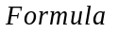 | Statistical formulae | 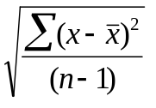

The course software

The course software

The course software is a public domain database and statistics package called EpiInfo and can be downloaded from the following website: http://www.cdc.gov/epo/epi/epiinfo.htm. This site also provides instructions on downloading the software and a phone number for technical assistance.

The course software is designed to run on any IBM compatible personal computer running MSDOS. You may also run the course software in a DOS window under Microsoft Windows, IBM OS/2, or using a PC emulator such as SoftPC or SoftWindows on a Macintosh, PowerPC, or UNIX machine.

The example dataset will be on your computer hard drive in the directory C:\CAPS as C:\CAPS\SFMHSHIV.REC.

For the purposes of this workbook we will be using the ANALYSIS module of EpiInfo. To use EpiInfo, double-click on the EpiInfo icon in the C:\CAPS directory. You will need to create a shortcut icon if one does not exist. ANALYSIS can read both EpiInfo and dBase format files. Using the mouse or arrow keys, go to the pull-down menu under Programs. Choose ANALYSIS of data.

Please acknowledge EpiInfo in any manuscript that makes use of its calculations. A suitable reference is:

Dean AG, Dean JA, Coulombier D, Brendel KA, Smith DC, Burton AH, Dicker RC, Sullivan K, Fagan RF, Arner TG (1994), EpiInfo, Version 6: A word processing, database and statistics program for epidemiology on microcomputers, Centres for Disease Control and Prevention, Atlanta, Georgia, USA.

The example dataset

Introduction to the study

The San Francisco Men's Health Study is a prospective epidemiological study designed to learn more about the natural history of Acquired Immune Deficiency Syndrome (AIDS). The study was funded by the National Institutes of Allergy and Infectious Disease (NIAID) under a contract with the University of California, Berkeley.

Several organizations cooperated in carrying out the San Francisco study. The Survey Research Center of the University of California, Berkeley, was responsible for questionnaire design, sampling, recruitment of participants, interviewing, coding and data management. The Children's Hospital of San Francisco was the location for the interviewing and provided the facilities for the physical examinations, the various clinical tests performed, and the collection of specimens, some of which were sent to NIAID. The Irwin Memorial Blood Bank of San Francisco performed most of the blood analysis and also stored frozen lymphocytes. Research on the specimens retained locally was carried out at the University of California, San Francisco.

The target population was defined as follows:

1. Residents of 19 census tracts in San Francisco. The tracts are 162-171, 204-207, and 210-214.
2. Men, currently unmarried, aged 25-54.
3. English speaking -- to avoid the cost of questionnaires in other languages for very few cases.

The sample was a stratified two-stage sample of all households within the target area. All eligible males in each selected housing unit were taken into the sample. There were 1043 interviews completed during the first wave of data collection. For details of the sample design and weighting, see the Survey Research Center Technical Report entitled "Sampling Methods and Wave 1 Field Results of the San Francisco Men's Health Study".

Work on the project began in September, 1983. The first year was devoted to the design of the project and the first wave of interviews. The study plan called for reinterviewing participants several additional times at six-month intervals.

The initial wave of interviews (N=1043) was conducted from 1 May 1984 to 11 April 1985. The final wave of interviews (N=527) began 5 January 1992 and ended 14 May 1993. In this text we will only use data from the initial wave. We will also ignore the complex survey structure and the sampling weights.

Further details of the study can be found in:

Winkelstein, W Jr; Samuel, M; Padian, N; Wiley, J; Lang, W; Anderson, R; Levy, J. The San Francisco Men’s Health Study: III. Reduction in Human Immunodeficiency Virus Transmission among Homosexual/Bisexual Men, 1982-86. AJPH, 1987 June, 76(9):685-689.

Lang, W; Anderson, RE; Perkins, H; Grant, RM; Lyman, D; Winkelstein, W Jr; Royce, R; Levy, JA. Clinical, immunologic, and serologic findings in men at risk for acquired immunodeficiency syndrome. The San Francisco Men's Health Study. JAMA, 1987 Jan 16, 257(3):326-30.

Winkelstein, W Jr; Lyman, DM; Padian, N; Grant, R; Samuel, M; Wiley, JA; Anderson, RE; Lang, W; Riggs, J; Levy, JA. Sexual practices and risk of infection by the human immunodeficiency virus. The San Francisco Men's Health Study. JAMA, 1987 Jan 16, 257(3):321-5.

Variable names, types, and ranges

The structure of the SFMHSHIV.REC dataset
Data from this study is stored in an EpiInfo data file called SFMHSHIV.REC. The following table lists the names, types, and ranges of variables in the SFMHSHIV.REC dataset. The variable types and the EpiInfo pictures that would be used to define variables in .QES files or with the DEFINE command in ANALYSIS are also listed:
Variable | Contents | Type | Picture | Values
ID | Subject ID number | Number | ##### | 54541 thru 59383
AGE | Age | Number | ## | Continuous (22-55)
RACE | Racial background | Number | # | 1 = White  2 = Hispanic  3 = Black  4 = Other
EDUC | Education level | Number | # | 1 = High school diploma or less  2 = College diploma or any college  3 = Graduate degree or classes
DEPRESD | Felt depressed in past week | Number | # | 1 = Rarely or none  2 = Some or a little  3 = Occasionally  4 = Most or all the time
SLEEP | Sleep was restless in the past week | Number | # | 1 = Rarely or none  2 = Some or a little  3 = Occasionally  4 = Most or all the time
ENJOYLF | Enjoyed life in the past week | Number | # | 1 = Rarely or none  2 = Some or a little  3 = Occasionally  4 = Most or all the time
SMOKER | Smokes cigarettes now | Number | # | 1 = Yes  2 = No
SMOKEAMT | Packs per day | Number | # | 1 = Less than ½ pack  2 = ½ pack to one pack  3 = 1-2 packs  4 = 2 or more packs
SEXPREF | Sexual orientation | Number | # | 1 = Homosexual or bisexual  2 = Heterosexual
NPARTNER | Number of male sex partners in past 2 years | Number | ### | Count (0-998)
NPARTC | Number of male sex partners in past 2 years (grouping of the variable NPARTNER) | Number | # | 0 = 0  1 = 1  2 = 2-9  3 = 10-49  4 = 50 or more
ANONSEX | Anonymous male sex partners in past 2 years | Number | # | 1 = Yes  2 = No
MARIJUAN | Used marijuana in past 2 years | Number | # | 1 = Yes  2 = No
POPPERS | Used poppers in past 2 years | Number | # | 1 = Yes  2 = No
COCAINE | Used cocaine in past 2 years | Number | # | 1 = Yes  2 = No
HALUCIN | Used halucinogens in past 2 years | Number | # | 1 = Yes  2 = No
DOWNERS | Used downers in past 2 years | Number | # | 1 = Yes  2 = No
UPPERS | Used uppers in past 2 years | Number | # | 1 = Yes  2 = No
OTHDRUG | Used other drugs in past 2 years | Number | # | 1 = Yes  2 = No
OTHDRT | Name of other drugs used in past 2 years | Character | <AAAAAAAAA> | MDA  ETHYL CHL  HEROIN
HEIGHT | Height in cm | Number | ### | Continuous (160-196)
WEIGHT | Weight in kg | Number | ### | Continuous (48-118)
CD4 | CD4+ cell count | Number | #### | Count (47-7107)
HIVSTAT | HIV test results | Number | # | 1 = Positive  2 = Negative
HIVLOAD | HIV viral load | Number | ####### | Continuous (398-3311311)
ANYDRUG | Used any drug in past 2 years | Number | # | 1 = Yes  2 = No
Categorical and continuous variable

The two broad groups

Variables can be split into two broad groups. These are:

Qualitative/Categorical variables that hold codes that indicate membership of a defined category or group. The variables RACE, EDUC, and SMOKEAMT are examples of categorical variables in the San Francisco Men’s Health Study dataset. Categorical variables can be stored as either numerical or non-numerical data. Even when stored as numerical data, the actual numerical values are typically not meaningful. A particularly common type of categorical variable is a binary categorical variable where cases can belong to one of two alternative groups. The variables SMOKER and HIVSTAT are examples of binary categorical variables in the San Francisco Men’s Health Study dataset. Categorical variables can be ordered (as with SMOKEAMT) or non-ordered (as with RACE).

Quantitative/Numerical variables that hold data that is measured and stored on an ordered numerical scale. The numerical information such variables hold is typically meaningful. There are two types of quantitative/numerical variables. Discrete variables hold data limited to distinct values, usually, but not always, whole numbers (integers). This includes data such as scores (scales) and counts. The variables NPARTNER, CD4, and HIVLOAD are examples of discrete variables in the San Francisco Men’s Health Study dataset. Continuous variables hold data that vary in a continuous range not constrained to distinct values. The variables HEIGHT and WEIGHT are continuous variables. In this workbook we will use the word “continuous” loosely to describe any quantitative/numerical variables with many values.

It is important that you appreciate the distinction between these two broad groups of variable as different techniques are used to describe and analyse them.
Files, cases, and variables

Files, cases, records, variables, and fields

A set of data (dataset) is stored in the computer as a file. A file consists of a collection of cases (or records), one for each individual. Each case contains the data on that individual in a series of variables (or fields):

Variables
Case
File
ID: #####
Age: ##
Race: #
Depresd: #
Sleep: #
Enjoylf: #
Smoker: #
Smokeamt: #
Sexpref: #

In our example, the cases would be individuals interviewed and the variables would be the answers to the questions asked (or scores calculated from those answers).

Data is usually represented in a table in which each row represents an individual case or record and each column represents a variable or field. Here are the first ten variables for the first three cases in the San Francisco Men’s Health Study:

ID | Age | Race | Educ | Depresd | Sleep | Enjoylf | Smoker | Smokeamt | Sexpref
54541 | 25 | 1 | 2 | 1 | 1 | 4 | 2 | . | 2
54544 | 49 | 1 | 3 | 4 | 1 | 2 | 2 | . | 2
54550 | 43 | 1 | 1 | 1 | 1 | 1 | 1 | 3 | 2

Note that there is no data in the SMOKEAMT variable for the first two cases. This is because the study subjects whose data is held in these two records were non-smokers (SMOKER = 2).
Retrieving a dataset in ANALYSIS

Retrieving a dataset

ANALYSIS is the data analysis module of EpiInfo. With ANALYSIS you can use simple commands to produce lists, frequencies, statistics and graphs. On the EpiInfo screen, choose ANALYSIS of data from the Programs pull-down menu (see page 8).

Once ANALYSIS starts the screen is divided into several distinct sections. The upper section is headed OUTPUT and the lower section is headed COMMANDS. At the top of the screen are two lines giving the status information:

Dataset: <None> Free memory: 250K
Use READ to choose a dataset

The status information shows the name of the current data file (dataset) and the amount of free memory in the system (this will depend on how your computer has been set up and is likely to differ from system to system). The bottom line of the screen shows the function keys available from within ANALYSIS:

Key | Function
l | Help
m | Menu of commands
n | Menu of variables in the current dataset
o | Browse the current dataset in ‘spreadsheet’ format
p | Printer on / Printer off
t | Temporary DOS session (type EXIT to get back to ANALYSIS)
u | Quit ANALYSIS

We need to tell ANALYSIS the name of the dataset we want to work with. The status information reminds you to do this:

Dataset: <None> Free memory: 250K
Use READ to choose a dataset

The data for the San Francisco Men’s Health Study is stored in an EpiInfo file called SFMHSHIV.REC. Type:

read sfmhshiv.rec

and press e. Alternatively, you can type read and press enter. You will be given a list of possible files with the ending “.REC”. Use the arrow keys to highlight the sfmhshiv.rec file and press enter. The name of the file and the number of records will appear at the top of the screen, indicating that the file has been read:

Dataset: C:\CAPS\SFMHSHIV.REC (1043 records) Free memory: 250K
Criteria: All records selected

Note that you need to press the e key to instruct ANALYSIS to act on any of the commands you type. You can edit the command line before you press e. The command is executed only after you press the e key. You can clear (i.e. delete) the command line by pressing |. ANALYSIS maintains a list of previously entered commands which you can scroll through using the w and y keys.

Examining a dataset

The BROWSE command

Look at the menu bar at the bottom of the screen showing the function keys available within ANALYSIS. Press the o key to browse through the data. The first twenty-one records appear on the screen, one record per line, with variables running across the line. Move around the file using the w, x, y, z, {, }, d and g keys. Their uses are:

Keys | Action
{, } | move up & down through the records (rows)
g, d | move to the top & bottom records (rows)
w, x, y, z | move between variables (columns) or records (rows)
b + z, b + x | move to the first & last variables (columns)

Press o again to select full screen mode. You now have a single record displayed above the menu bar. Look at the menu bar and work out how to move to the next record and back to the previous one. Try this a few times. Press o again to return to ‘spreadsheet’ mode. When you have finished looking at the data press u to return to the main ANALYSIS screen. Note that the word BROWSE appeared in the COMMANDS window, as a result of pressing o. We could have typed the command BROWSE instead of pressing the o key.

The LIST command

If we want to see the variables in a dataset and examine them variable-by-variable and record-by-record we would use the BROWSE command. If we want to see data as a list we would use the LIST command. Type:

list age race educ sexpref npartner anonsex

The AGE, RACE, EDUC, SEXPREF, NPARTNER, and ANONSEX variables (together with the internal record number) for all cases in the dataset are listed on the output screen. Since it is impossible to view all 1043 cases on the screen at the same time, they are listed a page at a time (each page showing fourteen cases). The word <more> at the bottom of the output screen means there are more pages of output to come. Press any key to see the next page of output. If you do not want to see any more output, press ^. When <more> no longer appears at the bottom of the output screen you are at the bottom of the listing. You can scroll back through the listing using the { and } keys. You can also use b with the { and } keys to scroll up and down the output screen one line at a time.

BROWSE and LIST commands

You can use the BROWSE and LIST commands on their own to view the entire dataset (i.e. all variables for all cases) or you can specify a list of variables to view. The command:

list npartner hivstat hivload

and the command:

browse npartner hivstat hivload

both allow you to examine the contents of the NPARTNER, HIVSTAT, and HIVLOAD variables. The BROWSE command is more flexible (‘spreadsheet’ and full-screen modes, easy scrolling between variables and cases, output not limited to the width of the screen) but sends output to the screen only. If you want to list variables and cases to a printer or file then you should use the LIST command.
Subsets of data

The SELECT command

If we wanted to work with data for a subset of cases we would use the SELECT command to select only those cases we wanted to work with. Type:

select sexpref = 2

Any subsequent commands we type will be performed only with the data for heterosexuals (SEXPREF = 2). Note that the status information at the top of the screen changes to reflect the SELECTion criteria:

Dataset: C:\CAPS\SFMHSHIV.REC (1043 records) Free memory: 250K
Criteria: sexpref = 2

Type the command:

list id age sexpref race

If we page through the output screen, we can see that only heterosexuals are listed. Now suppose we want to work with the homosexual/bisexual subjects (SEXPREF = 1). If we type:

select sexpref = 1

No records will be SELECTed (check this using the LIST or BROWSE commands). This is because there can be no cases where SEXPREF = 2 and SEXPREF = 1 at the same time:

Dataset: C:\CAPS\SFMHSHIV.REC (1043 records) Free memory: 250K
Criteria: (sexpref = 2) AND (sexpref = 1)

What we must do is cancel the previous SELECT statement, so that all records are SELECTed again. Type:

select

The SELECT command on its own instructs ANALYSIS to work with all the cases in a dataset. Note that the SELECTion criteria at the top of the screen now shows that all records are selected:

Dataset: C:\CAPS\SFMHSHIV.REC (1043 records) Free memory: 250K
Criteria: All records selected

Issue another SELECT command to SELECT the homosexuals/bisexuals:

select sexpref = 1

Examine the SELECTion criteria at the top of the screen. Use the BROWSE or LIST command and scroll through the listing to check that this new SELECT command has worked as expected.

Issue the SELECT command on its own:

select

to clear the current SELECTion criteria and continue working with all records in the dataset.

Subsets of data

More complex selections

The expression (e.g. ‘SEXPREF = 1’) used with the SELECT command can be a complex expression using a combination of inequality operators:

Operator | Meaning | Example
= | equal to | sexpref = 1  othdrt = “heroin”
<> | not equal to | sexpref <> 1
< | less than | age < 35
> | greater than | age > 35
<= | less than or equal to | age <= 35
>= | greater than or equal to | age >= 35

and Boolean operators:

Operator | Meaning | Example
and | both expressions must be true | sexpref = 1 and age < 35
or | either of the expressions may be true | sexpref = 1 or age < 35
not | the expression must not be true | sexpref = 1 and not age < 35

Boolean operators are symbols used to express logic and to test the validity (truth) of a logical expression in an algebraic way. Boolean operators always separate expressions that can only be true or false (e.g. ‘Is the age less than 35?’) and always return true or false values. Here are the truth tables for the AND and OR Boolean operators:

AND |  |  |  | OR
First Expression | Second Expression | Resulting Expression |  | First Expression | Second Expression | Resulting Expression
false | false | false |  | false | false | false
true | false | false |  | true | false | true
false | true | false |  | false | true | true
true | true | true |  | true | true | true

The NOT operator reverses the resulting expression (i.e. true becomes false and false becomes true).

Parentheses can be used to create complex expressions or to group expressions. Examples are:

Example | Selected Cases
sexpref = 2 | Heterosexuals
sexpref = 2 and smoker = 1 | Heterosexuals who smoke
sexpref = 2 and smoker = 1 and race = 1 | White heterosexuals who smoke
sexpref = 2 or smoker = 1 | Heterosexuals and smokers
sexpref = 2 or (smoker = 1 and race = 1) | Heterosexuals and white smokers

The Boolean operators may appear to work against common sense but it is not difficult to build expressions using them as long as you remember that AND excludes cases (all expressions must be true) whereas OR includes them (only one expression need be true).
Subsets of data

When to use quotes with SELECT

You may have noticed that some of the SELECTion expressions in the examples had selection values enclosed in double-quote characters (") whilst others did not. The use of double-quote characters depends on the variable type. You should use double-quotes with character variables but not with number variables. You can list variable names, types and lengths using the command:

variables

Number variables are marked Integer or Real. Character variables are marked ALPHA or string. If you use double-quote characters with a number variable the SELECT command will function correctly only with the equality (=) operator. Note that single quotes (‘) will not work with either type of variable.

Entering commands in ANALYSIS

There are two methods of issuing commands to the ANALYSIS program. You may either type the command directly at the keyboard or choose commands and variables from menus.

Pressing the m key brings up a menu of available commands. To select a command from the menu you must first move the highlighted bar using the arrow keys. When the highlighted bar is over the command you wish to use press e to select it. To execute the command press e again. With most commands you will need to specify at least one variable.

Pressing the n key brings up a menu of variables in the current dataset. Variables can be selected from the menu in the usual way. To select just one variable point to it using the arrow keys and press e. To select a group of variables point to each one in turn and press the + key. When you have selected all the variables you need press e. If you select a variable by mistake you can deselect it using the - key.

Getting help on commands

There are two ways of getting help on commands in ANALYSIS. If you press l before you have typed a command then ANALYSIS will present you with a menu with options for help on general topics and specific commands. Options are selected from the menu in the usual way. If you want help on a specific command then type the command (e.g. LIST) and press l. ANALYSIS will respond with help for the command you typed.

If there is more than one screen of help on a particular topic or command then PgDn will be displayed in the bottom right hand corner of the help window. Pressing }will display the next screen of information.

Press ^ to return to ANALYSIS.

Leaving ANALYSIS

To leave ANALYSIS press u or type the command:

quit

and press e. This will return you to the EpiInfo program screen.
Producing charts

The shape of data

Charts are an ideal way of looking at how data in a variable is distributed. The distribution of a variable can be thought of as the shape of the data in that variable. Using charts we can see the shape of the data and answer the following types of questions about a variable:

Are the data values similar to each other?

Are the data values different from each other?

How different are the data values from each other?

Is there a single group of data values?

Are there several groups or clusters of data values?

Are a few data values very different from the majority of data values?

Questions like these cannot easily be answered by looking at a list of the data values in a variable. Charts allow us to see important features in the data. A chart is a picture of the data that allows us to see the overall structure of data rather than the confusing detail of individual data values.

Producing charts

ANALYSIS chart types

You can produce five different types of chart with ANALYSIS:

ANALYSIS Command | Chart Type
pie variable | Pie chart of the specified variable
bar variable | Bar chart of the specified variable
histogram variable | Histogram of the specified variable
line variable-1 [variable-2] | Line plot of variable-1 [by levels of variable-2]
scatter x-variable y-variable [/r] | scatter plot of two variables [with regression line]

Start ANALYSIS and retrieve the San Francisco Men’s Health Study dataset by typing:

read sfmhshiv.rec

Suppose we want to examine the distribution of the RACE (racial background) variable. We could produce a BAR chart by typing:

bar race

After examining the chart, we can remove it from the screen by pressing ^ (the graph does not appear in the output screen). You can produce a HISTOGRAM of the AGE variable using the HISTOGRAM command:

histogram age

You can produce a PIE chart of the EDUC (education) variable using the PIE command:

pie educ

or a LINE plot (frequency polygon) of the AGE variable using the LINE command:

line age

You can also use the LINE command to examine the difference between groups. The command:

line age sexpref

shows separate lines for heterosexuals and homosexuals/bisexuals. The labels for the lines (1 and 2) are taken from the values of the SEXPREF variable (i.e. 1 = homosexual/bisexual, 2 = heterosexual).

To produce a SCATTER plot of two variables, showing how one varies with the other, use the SCATTER command which takes the general form:

scatter x-variable y-variable

The first variable listed (x-variable) will be plotted along the horizontal (x) axis and the second variable listed (y-variable) will be plotted along the vertical (y) axis as in:

scatter height weight

If you add ‘/r’ to the end of a SCATTER command it will display a regression line showing the linear (straight line) relationship between the two variables:

scatter height weight /r
Chart types and their uses

Analysis chart types and their uses

Each type of chart has a different use. The table below summarises their use:

Chart | Examples | Description
PIE | pie educ  pie race | Used to display the proportion (percentage) of cases for each value of a categorical variable. Segments of the pie represent the proportion of cases with different values of the variable. Pie charts should be used for non-ordered data (e.g. sexual preference). They are not appropriate for ordered data (e.g. age groups) and can be difficult to read when used to chart variables with more than five or six values (categories). Bar charts are preferred to pie charts when used to chart ordered data or non-ordered data with more than five or six categories.
BAR | bar educ  bar race  bar sleep | Used to display the count of cases in each category of a categorical variable. Vertical bars represent counts of cases with different values of the variable. Bar charts differ from histograms in having bars separated by spaces and in omitting counts for values (categories) with a count of zero.
HISTOGRAM | histogram age  histogram height  histogram weight | Used to display the distribution of values in a (continuous or count) quantitative/numerical variable. Vertical bars represent counts of records with different values of the variable. Histograms differ from bar graphs in having the bars contiguous (not separated by spaces) and in displaying counts for values with a count of zero.
LINE | line age  line age sexpref | Used to display the distribution of values in a (continuous or count) quantitative/numerical variable. Points on the line represent counts of cases with different values of the variable. More than one line may be charted by giving the name of an additional (categorical) stratifying variable. Charts with multiple lines can be difficult to read when the stratifying variable has more than three or four categories (i.e. when the chart displays more than three or four lines). Line charts are often used to show trends or movement in the value of a variable over time (time-series).
SCATTER | scatter height weight | Used to investigate and display the relationship between two continuous variables. Points on the scatter plot represent pairs of values (i.e. the values for each of the variables within the same case). The first value (x) defines the horizontal position of the point. The second value (y) defines the vertical position of the point. For example, the value pair (3,4) would be represented as:  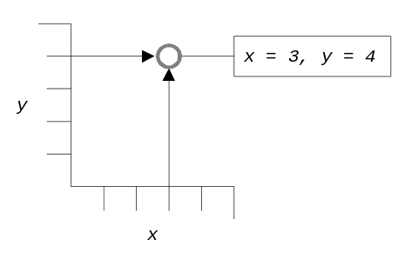  A non-random appearance to the plot indicates that there is an association between the two variables.
Practical exercises

Variables and variable names

For a full explanation of variables, their names, and their codes refer to the table on page 10.

Exercise 1 - Examining a dataset

How many cases are there in the dataset stored in SFMHSHIV.REC?

SELECT only those persons who are SMOKERs. Use BROWSE or LIST to see how many records are selected in each of the HIVSTAT groups (positive and negative).

Clear the SELECTion so that you can continue to work with all of the cases.

SELECT only those persons who are not White. Use BROWSE or LIST to see how many records are selected.

Clear the SELECTion so that you can continue to work with all of the cases.

SELECT only those persons who are both Hispanic and homosexual/bisexual. Use BROWSE or LIST to see how many records are selected in each of the HIVSTAT groups (positive and negative).

Clear the SELECTion so that you can continue to work with all of the cases.

Exercise 2 - Producing charts

Produce a BAR chart of RACE. Which is the most common racial background?

Produce a PIE chart of EDUCation. What percentage of the study population either has a graduate degree or has attended graduate school?

Produce a HISTOGRAM, PIE chart, and LINE plot of the AGE variable. Which chart do you think is the most appropriate and why? What was the highest and lowest age recorded for any person?

Produce a SCATTER plot of the HEIGHT and WEIGHT variables. Produce the same chart again but with a regression line. Do the points seem to lie close to the line?

Summarising distributions

Frequency distributions

The frequency distribution, percentage frequency distribution and cumulative percentage frequency distribution of a variable can be produced using the FREQ command:

freq race

This can be done for several variables in the same command:

freq race depresd sleep

The FREQ command produces a table listing counts, percentages, and cumulative percentages for each value of the specified variable. If the variable is numerical, the FREQ command will also display some summary statistics which may (or may not) be meaningful:

RACE | Freq Percent Cum.
------+-----------------------
1 | 897 86.6% 86.6%
2 | 52 5.0% 91.6%
3 | 52 5.0% 96.6%
4 | 35 3.4% 100.0%
------+-----------------------
Total | 1036 100.0%

Total Sum Mean Variance Std Dev Std Err
1036 1297 1.252 0.492 0.701 0.022

Minimum 25%ile Median 75%ile Maximum Mode
1.000 1.000 1.000 1.000 4.000 1.000

Student's "t", testing whether mean differs from zero.
T statistic = 57.447, df = 1035 p-value = 0.00000

In this case the summary statistics (sum, mean, standard deviation, etc.), with the exception of the mode, are meaningless because RACE is a categorical variable (i.e. it contains codes that indicate membership of mutually exclusive categories). The quoted value for the mean (1.252) does not point somewhere between being White and Hispanic. The mean and standard deviation are not of use when dealing with categorical data. Many ANALYSIS commands will provide summary statistics and the results of statistical tests whether they are appropriate or not. It is up to you to decide if the output of any command is relevant.

Use the l help key to find out more about the FREQ command. Practice using the FREQ command with other variables.

Examine the output of the FREQ command carefully, making sure that you can interpret it.
Practical exercise

Variables and variable names

For a full explanation of variables, their names, and their codes refer to the table on page 10.

Exercise 3 - Summarising distributions

Use the FREQ command to examine the distribution of the NPARTC variable (number of male sexual partners). For how many subjects was the number of male sexual partners equal to zero? What was the most common NPARTC value? For how many subjects was the number of male sexual partners greater than or equal to 50?

Use the FREQ command to examine the distribution of the SMOKEAMT variable. Note that the variable is only defined for smokers. What percentage of subjects who smoked cigarettes smoked less than ½ pack per day? What percentage smoked ½ pack to one pack per day? What percentage smoked 2 or more packs per day?

The table below was produced using the command FREQ SMOKEAMT. Examine the table carefully and mark on the table the positions of the values of the variable, the counts for each value of the variable, the percentage for each value of the variable, the cumulative percentages, and the total number of cases:

SMOKEAMT | Freq Percent Cum.
---------+-----------------------
1 | 50 12.4% 12.4%
2 | 87 21.6% 34.0%
3 | 192 47.6% 81.6%
4 | 74 18.4% 100.0%
---------+-----------------------
Total | 403 100.0%

Total Sum Mean Variance Std Dev Std Err
403 1096 2.720 0.819 0.905 0.045

Minimum 25%ile Median 75%ile Maximum Mode
1.000 2.000 3.000 3.000 4.000 3.000

Student's "t", testing whether mean differs from zero.
T statistic = 60.321, df = 402 p-value = -0.00000

What problems might there be in using the sum, mean, variance, standard deviation, and standard error (the first line of statistics) to summarise this distribution? Does the Student’s “t” make sense?

Use the BAR or PIE command to chart the distribution of the SMOKEAMT variable.
Summarising distributions

Categorical variables

Variables such as RACE, EDUC, and DEPRESD are stored as a set of mutually exclusive codes. Such variables are known as categorical variables. The RACE variable, for example, is coded:

Code | Meaning
1 | White
2 | Hispanic
3 | Black
4 | Other

With categorical variables it makes sense to use the FREQ command to produce a frequency distribution as this allows us to investigate the count (i.e. number) and proportion of cases that belong to each group and to identify groups with many or few members:

RACE | Freq Percent Cum.
-------+-----------------------
1 | 897 86.6% 86.6% <- Largest (modal) group
2 | 52 5.0% 91.6%
3 | 52 5.0% 96.6%
4 | 35 3.4% 100.0% <- Smallest group
-------+-----------------------
Total | 1036 100.0%

Total Sum Mean Variance Std Dev Std Err
1036 1297 1.252 0.492 0.701 0.022

Minimum 25%ile Median 75%ile Maximum Mode
1.000 1.000 1.000 1.000 4.000 1.000

Student's "t", testing whether mean differs from zero.
T statistic = 57.447, df = 1035 p-value = 0.00000

Beware of the summary statistics presented below this frequency table (with the exception of Total and Mode) as they are meaningless for categorical variables such as RACE, EDUC, and DEPRESD.

“Continuous” variables

Some variables, such as AGE, NPARTNER, CD4, and HIVLOAD, hold quantitative data with many values. A frequency distribution is of different use with such variables as each value will account for only a small proportion of cases and does little to help us understand how the variable is distributed. As an example, produce a frequency distribution of the HEIGHT variable by issuing the command:

freq height

If you study the resulting table closely enough you will be able to extract some useful information from it.
Frequency distributions of continuous data

Summarising continuous data with a frequency table

This is the frequency distribution of the HEIGHT variable. Important information has been highlighted:

HEIGHT| Freq Percent Cum.
------+-----------------------
160 | 14 1.4% 1.4% <- minimum value
163 | 11 1.1% 2.4%
165 | 37 3.6% 6.0%
168 | 56 5.4% 11.4%
170 | 92 8.9% 20.3%
173 | 138 13.3% 33.6%
175 | 134 12.9% 46.6%
178 | 143 13.8% 60.4% <- most common (modal) & middle (median) values
180 | 129 12.5% 72.9%
183 | 113 10.9% 83.8%
185 | 79 7.6% 91.4%
188 | 48 4.6% 96.0%
191 | 17 1.6% 97.7%
193 | 15 1.4% 99.1%
196 | 9 0.9% 100.0% <- maximum value
------+-----------------------
Total | 1035 100.0% <- number of observations (cases)

Total Sum Mean Variance Std Dev Std Err
1035 183408 177.206 48.289 6.949 0.216

Minimum 25%ile Median 75%ile Maximum Mode
160.000 173.000 178.000 183.000 196.000 178.000

Student's "t", testing whether mean differs from zero.
T statistic = 820.394, df = 1034 p-value = 0.00000

The highlighted information is known as the seven figure summary and can be used to summarise the distribution of quantitative/numerical data. The seven summary measures are:

summary measure | formula | description
minimum | NONE | lowest value in the dataset
median | NONE | middle item in the dataset
mode | NONE | most common value in the dataset
maximum | NONE | highest value in the dataset
number of observations (n) | NONE | number of observations (cases)
mean () | 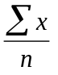 | sum of the observations divided by the number of observations
standard deviation (s) | 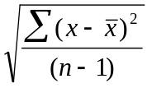 | a measure of how much the distribution varies around the mean

Some texts refer to this as the six figure summary. This is because they replace the minimum and maximum with the range which is the difference between the maximum value and the minimum value.

Note that in this example the modal (most frequent) and median (middle) values are the same. This will not always be the case.
Summarising distributions of continuous data

The seven figure summary

With continuous data we are not interested in the counts of cases for each particular height, weight, or score. We are more interested in the complete distribution. This can be summarised with two separate measures: A measure of the central tendency and a measure of the variability of the data. The seven figure summary yields both measures:

Measuring | Measure
central tendency | mode  median  mean
variability | range (maximum - minimum)  standard deviation

To understand why you need to examine both central tendency and variability consider the following two distributions:

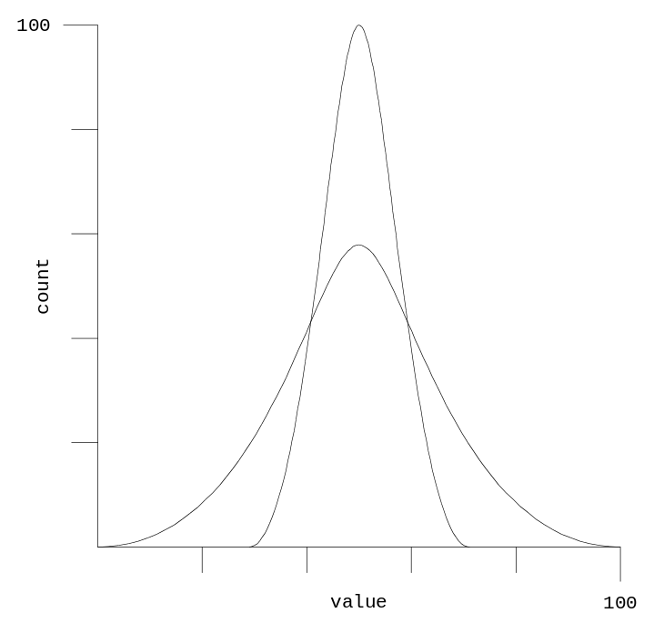

The two distributions shown on the graph have similar mean, median, and modal values. If we just used these measures of central tendency to describe the distributions we would not be describing them properly. We would conclude that they were the same as each other. As well as reporting the central tendency we also need to report the variability of the two distributions using the range and the standard deviation:

measure | wide | narrow
mean | 50 | 50
median | 50 | 50
mode | 50 | 50
range | 100 | 50
standard deviation | 15 | 8

This allows us to see that one distribution has a wider range of values (i.e. it is more variable) than the other.
Summarising distributions of continuous data

How the standard deviation measures variability

The formula for the standard deviation appears complicated:

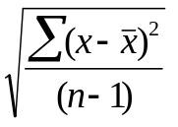

but it can be easily understood once broken down into its component steps. The formula relies on subtracting the mean from each data value:

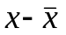

and summing (adding up) the deviations (differences):

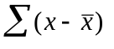

The positive and negative deviations will cancel each other out (giving zero) so each of the deviations is squared (multiplied by itself) to give positive values before summation:

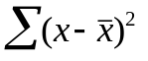

The sum of the squared deviations is divided by the number of cases contributing to the mean minus one:

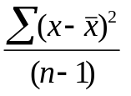

This gives a measure of average deviation from the mean which is known as the variance. The variance is expressed in squared units which are difficult to interpret. To get over this problem, the square root of the variance is used:

This measure is known as the standard deviation and is a measure of average deviation from the mean expressed in the original unit of measure. The more variable the data, the larger the standard deviation will be.

The Greek letter sigma (Σ) is used in statistical formulae to denote the sum of a series of numbers. Squaring a number (multiplying a number by itself) is a convenient way of turning negative numbers into positive numbers and is used in many statistical formulae for this purpose.

Standard deviation - worked example

Calculating the standard deviation

The table below shows four data points, their sum, and their mean:

 | Data
 | 3
 | 7
 | 6
 | 4
Sum | 20
Mean | 5

The first step in calculating the standard deviation is to subtract the mean from each data point to give the deviation of each data point from the mean:

 | Data | point - mean
 | 3 | -2
 | 7 | +2
 | 6 | +1
 | 4 | -1
Sum | 20 | 0
Mean | 5

Because the deviations add-up to zero, they are squared to make them all positive numbers:

 | Data | point - mean | (point - mean)2
 | 3 | -2 | 4
 | 7 | +2 | 4
 | 6 | +1 | 1
 | 4 | -1 | 1
Sum | 20 | 0 | 10
Mean | 5

Dividing the sum of the squared deviations by the number of data points minus one gives us the variance:

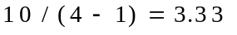

Taking the square root of the variance gives us the standard deviation:

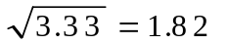

Standard deviation and degrees of freedom

Why use n - 1 instead of n to calculate the standard deviation?

The standard deviation is calculated by taking the square root of the sum of the squared deviations from the mean divided by the number of cases minus one:

Note that n - 1 is used to calculate the average squared deviation. This is because subtracting the mean from each value leads to the ‘loss’ of one item of data. The deviations may not be any group of n numbers. The sum of the deviations is always zero. When n - 1 deviations are specified, the last one is determined by the condition that they sum to zero:

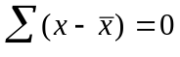

The final deviation is the sum of the other deviations with a change of sign (i.e. a positive number will become negative or a negative number will become positive). This is known as the loss of a degree of freedom. The deviations have n - 1 degrees of freedom because the final deviation has to have a particular value once n - 1 deviations are specified. You can see this ‘loss’ in this example with four data points:

 | Data | n deviations | n - 1 deviations
 | 3 | -2 | -2
 | 7 | +2 | +2
 | 6 | +1 | +1
 | 4 | -1 | ??
Sum | 20 | 0 | +1
Mean | 5

The sum of n - 1 deviations determines the value of the missing deviation which is marked ‘??’ in the table. The sum of n - 1 deviations is +1 so the missing deviation must be -1 because the sum of all deviations must be zero. As the missing deviation can be determined from n - 1 deviations and the constraint that the sum of deviations must be zero, there are really only n - 1 pieces of information (degrees of freedom) for the deviations.

The range and the standard deviation

Both the range and the standard deviation measure variability. The range is simple to calculate but has an undesirable property. It is calculated using the two extreme values only (the minimum value and the maximum value). Any outliers (extremely high or low values) will be included in these extremes making the range extremely sensitive to (potentially erroneous or unrepresentative) outliers in the data. The standard deviation is often preferred to the range because all data points (not just two) are used and it is less effected (but may still be distorted) by outliers in the data.

Problems with the mean and standard deviation

The normal distribution

The mean and standard deviations describe a particular type of distribution very well. This distribution is symmetrical and bell shaped with mean, median and mode similar to each other:

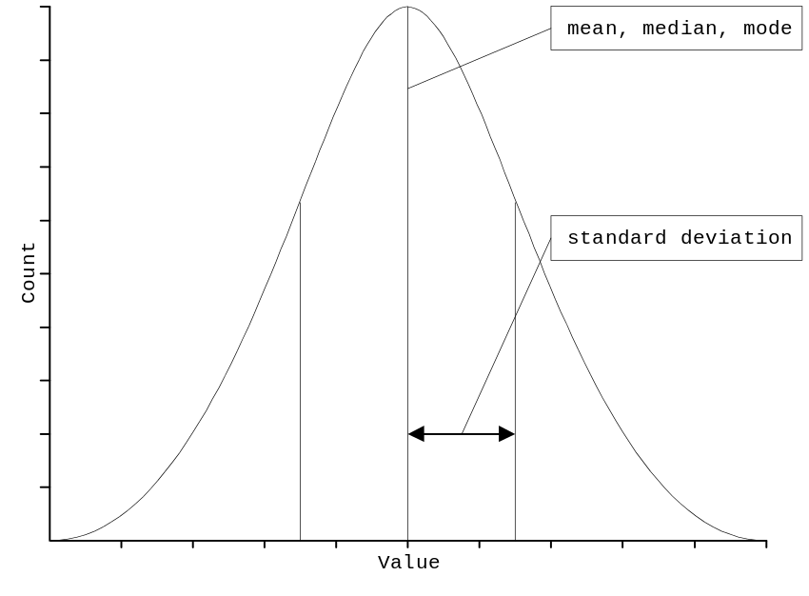

and is called the normal distribution. If your data has a very different type of distribution then the mean and standard deviation may not describe the distribution well. With non-normal distributions it may be best to use alternative measures of central tendency (e.g. the median) and variability (e.g. the range or inter-quartile distance) or apply a transformation to your data to bring it closer to the normal distribution (types of distribution and the range of transformations that can be applied to them are covered on pages 65 - 70).

Fortunately, the normal distribution is very common in nature. Many of the variables you collect will be normally distributed and you will be able to use the mean and standard deviation to describe them accurately.

It is very unlikely that you will see a perfectly normal distribution each time you chart your data. Random variation in the data will tend to make the distributions look ragged and may also make the distribution slightly non-symmetrical. There will usually be a few extreme or outlier values in the left and right tails of the distribution. If the data values tend to cluster in a symmetrical manner around a central value and there are progressively fewer and fewer data values as you move outward from the middle value and there are no data values that are very far way from the bulk of the other data values then you may safely assume that the data come from a variable that is normally distributed and that it is reasonable to use the mean and standard deviation to summarise the distribution.
Summarising distributions of continuous data

Calculating summary measures in analysis

ANALYSIS provides the DESCRIBE command for dealing with continuous data. The DESCRIBE command produces summary measures. Issue the command:

describe height

to instruct ANALYSIS to calculate and display summary measures for the HEIGHT variable. The command produces a table showing summary measures:

Variable Obs Total Mean Variance Std Dev
HEIGHT 1035 183408.000 177.206 48.289 6.949

You can instruct ANALYSIS to display the cut-point values for the quartiles and the minimum, maximum, and modal values by adding “/all” to the end of the command line:

describe height /all

which gives the following ouput:

Variable Obs Total Mean Variance Std Dev
HEIGHT 1035 183408.000 177.206 48.289 6.949

Variable Minimum 25%ile Median 75%ile Maximum Mode
HEIGHT 160.000 173.000 178.000 183.000 196.000 178.000

These values divide the distribution into four equal sized groups and can also be a useful way of summarising a distribution. The 25th percentile (lower quartile) and the 75th percentile (upper quartile) are the boundary values for the middle 50% of the data. The interquartile range or interquartile distance (i.e. 75th percentile - 25th percentile) is sometimes used as an alternative measure of variability. The advantage of using the interquartile range (instead of the range or the standard deviation) is that it is not effected by outliers.

Summarising distributions with charts

Categorical data

You can summarise categorical data using BAR and PIE charts. This is because these charts plot absolute counts (BAR charts) and counts as a proportion (percentage) of the sample population (PIE charts). Issue the following commands:

pie race
bar race

Both charts show the same thing. They are graphical equivalents of the FREQ command. The BAR chart shows counts and the PIE chart shows proportions (percentages).

Continuous data

Continuous data can be summarised using either histograms or line charts. Issue the following commands:

histogram age
line age

This sort of line chart is sometimes called a frequency polygon. You can also use the LINE command to show the distribution of a continuous variable grouped by levels (values or categories) of a categorical variable. Issue the command:

line age sexpref

The labels for the lines (1 and 2) are taken from the values of the SEXPREF variable.

A more useful histogram would be for age in categories, rather than age itself (see page 34).

Practical exercise

Variables and variable names

For a full explanation of variables, their names, and their codes refer to the table on page 10.

Exercise 4 - Summarising distributions

Use the DESCRIBE command to produce the seven figure summaries for the AGE, NPARTNER, HEIGHT, WEIGHT, and CD4 variables and complete the following table:

 | AGE | NPARTNER | HEIGHT | WEIGHT | CD4
number of cases
mode
median
mean
minimum
maximum
standard deviation

Use the HISTOGRAM command to graph the distributions of the AGE, HEIGHT, and WEIGHT variables.

The command:

histogram age

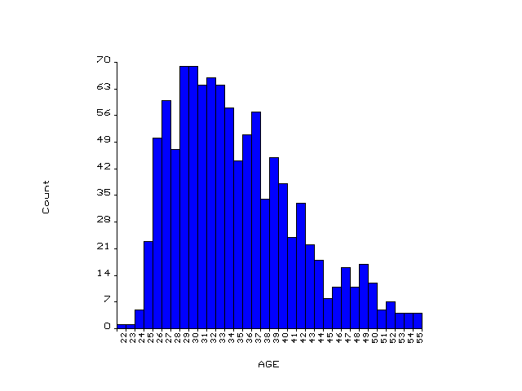 produces the following graph:

Mark the mode, median, and mean, minimum, and maximum (from the previous part of this exercise) on this graph.
Creating and recoding variables

The DEFINE command

To create a new variable (e.g. AGEGROUP) you first need to tell ANALYSIS what kind of variable AGEGROUP will be using the DEFINE command. Variable types that could be used for the new variable are:

Name | Typical Values | Variable Type | DEFINE ‘Code’
AGEGROUP | 1, 2 | Number | #
AGEGROUP | Y, N | Logical (Yes/No) | <Y>
AGEGROUP | +, - | Character | <A>
AGEGROUP | "YOUNG", "OLD" | Character | <AAAAA>

Issue the command:

define agegroup #

to create a new number variable called AGEGROUP. The number of # signs defines the length of the new variable. Use the ANALYSIS help system to discover how other codes can be used with the DEFINE command.

Press o or type BROWSE. You should see a blank column at the right hand side of the data file which has the heading AGEGROUP (you may need to press x or b+x to see this new column). ANALYSIS has assigned a new character column for this variable. At present all the values are blank (or ‘missing’).

Recoding “continuous” variables into categorical variables

Issue the command:

recode age to agegroup lo-29=1 30-39=2 40-49=3 50-hi=4

to RECODE the variable AGE into the variable AGEGROUP. The RECODE command must be issued after defining the new variable. Your data file now has the original variable AGE and a new variable AGEGROUP. The choice of cut-points for group membership is often arbitrary and can make a difference to the results of analysis. Sometimes an agreed definition of cut-points for (e.g.) high and low groups for a particular continuous measure will not be available. With these variables, you might choose cut-points such as the mean, median, mode, or quartiles.

After using RECODE you should always check to see if the command has had the expected result using the LIST or BROWSE commands:

list age agegroup
browse age agegroup

An alternative way of recoding data is to use the IF ... THEN command. Try this by typing:

define htgroup <AAAAAA>
if height <= 173 and height <> . then htgroup = "SHORT"
if height >= 174 and height <= 182 then htgroup = "MEDIUM"
if height >= 183 then htgroup = "TALL"

In this example the lower and upper quartiles (found using the DESCRIBE command) have been chosen as cut-points. Check the results of the IF ... THEN commands using the o BROWSE command (you will need to press x or b+x to view the new column). Examine the distribution of HTGROUP using the FREQ command.
Creating and recoding variables

Another use for RECODE

A problem with the LINE and HISTOGRAM commands in ANALYSIS is that they do not group data automatically. This can often make it difficult to see the underlying distribution. Enter the command:

histogram weight

It might be easier to examine the distribution of the variable if it were grouped into 10kg categories. Issue the commands:

define wtgroup ###
recode weight to wtgroup 40-49=45 50-59=55 60-69=65 70-79=75 80-89=85
90-99=95 100-109=105 110-119=115

to group the values of the WEIGHT variable into six groups (or intervals). Please note that the RECODE command should be typed on a single line. You should not press the [Enter] key after you have entered the text "80-89=85". Type the entire command before pressing the [Enter] key.

Use the BROWSE or LIST command to check that the commands have had the desired effect. Issue the command:

histogram wtgroup
freq wtgroup

It is easier to examine the distribution of the data, particularly the proportion of subjects in the tails of the distribution (i.e. those subjects with either low or high weights).

WTGROUP ¦ Freq Percent Cum.
--------+-----------------------
45 ¦ 1 0.1% 0.1% <- Low weights
55 ¦ 60 5.8% 5.9%
65 ¦ 288 27.9% 33.9%
75 ¦ 374 36.3% 70.1%
85 ¦ 197 19.1% 89.2%
95 ¦ 79 7.7% 96.9%
105 ¦ 18 1.7% 98.6%
115 ¦ 14 1.4% 100.0% <- High weights
--------+-----------------------
Total ¦ 1031 100.0%
Creating and recoding variables

Rules for recoding continuous data

There are four rules that you should follow when recoding continuous data into intervals:

- The groups you create must be mutually exclusive. The same value must not be assigned to more than one group. For example, a RECODE command with the form:

recode weight to wtgroup 40-50=45 50-60=55 60-70=65 ...

is ambiguous for cases where WEIGHT = 50 or WEIGHT = 60.

- The intervals should be of the same width. Different interval widths can make the histogram difficult to interpret. The commands:

define wtdiff ###
recode weight to wtdiff 40-49=45 50-59=55 60-64=62 65-69=67 70-79=75 80-84=82 85-89=87 90-99=95 100-110=105 111-120=115
histogram wtdiff

give a wrong picture of the underlying distribution of the WEIGHT variable.

- You should choose enough groups (i.e. the groups should be narrow enough) to show some of the variation in the data. The commands:

define wtfew ###
recode weight to wtfew 40-79=60 80-120=100
histogram meefew

also give a wrong picture of the underlying distribution of the WEIGHT variable. Between five and ten groups is usually sufficient.

- The groups must cover all values of the variable being grouped.

These rules only apply to investigating the underlying distribution of a variable and need not apply to grouping a variable in another context. ANALYSIS provides a quick way of recoding data into equal width intervals using the BY keyword. The commands:

define wtquick <AAAAAAAAAA>
if weight <> . then recode weight to wtquick by 10

will recode the WEIGHT variable into groups of width ten. Note that the recode line begins with the expression “if weight <> .” so that missing values of WEIGHT will continue to be missing for the WTQUICK variable.

Examine the distribution of the WTQUICK variable using the FREQ and HISTOGRAM commands.

freq wtquick
histogram wtquick
Creating and recoding variables

Recoding categorical variables

So far we have used the RECODE and IF ... THEN commands to RECODE continuous variables into categorical variables. You can also use these commands to RECODE categorical variables.

With the San Francisco Men’s Health Study data, it is possible to explore whether non-white race is associated with HIV infection status. The RACE variable is distributed as follows:

RACE | Freq Percent Cum.
------+-----------------------
1 | 897 86.6% 86.6%
2 | 52 5.0% 91.6%
3 | 52 5.0% 96.6%
4 | 35 3.4% 100.0%
------+-----------------------
Total | 1036 100.0%

These four groups need to be collapsed into two groups to explore this hypothesis. To do this we must first define a new variable:

define white #

and then use the RECODE command to create the two groups:

recode race to white 1=1 2,3,4=2

and finally use the BROWSE command to check the effect of these commands:

browse race white

Now that we have two variables WHITE and HIVSTAT which are coded as binary categorical variables we can use the TABLES command to produce a two-by-two table to investigate the hypothesis that non-white race is associated with HIV infection status:

tables white hivstat

Two-by-two tables

Two-by-two tables : Naming of parts

Measures of association between two variables are easily studied by means of two-by-two contingency tables. Such a table is presented below:

Outcome

Exposure | Cases | Non-Cases | Totals
------------+---------------+---------------+--------------
Present | a | b | a + b
------------+---------------+---------------+--------------
Absent | c | d | c + d
------------+-------------------------------+--------------
Totals | a + c | b + d | a + b + c + d

a = number exposed and ill
b = number exposed and not ill
c = number unexposed and ill
d = number unexposed and not ill
a + b = number exposed
c + d = number unexposed
a + c = number ill
b + d = number not ill
a + b + c + d = number in study

With the San Francisco Men’s Health Study data, the command:

tables poppers hivstat

produces the following table:

HIVSTAT
POPPERS | 1 2 | Total
------------+-----------------------+------
1 | 348 272 | 620
2 | 60 353 | 413
------------+-----------------------+------
Total | 408 625 | 1033

as well as some summary statistics which we will cover later in the book. In this table our exposure variable is POPPERS and our outcome variable is HIVSTAT. Using the terms introduced above we have:

a = 348 = number exposed and ill
b = 272 = number exposed and not ill
c = 60 = number unexposed and ill
d = 353 = number unexposed and not ill
a + b = 620 = number exposed
c + d = 413 = number unexposed
a + c = 408 = number ill
b + d = 625 = number not ill
a + b + c + d = 1033 = number in study (excluding those with missing values)

In this example exposed means use of poppers within the past two years and ill means being infected with HIV. Make sure that you can identify these figures in the table before proceeding.

Two-by-two tables

The crude risk

The crude risk is the risk of an outcome happening to an individual belonging to a given population. This can be calculated from a 2-by-2 table as:

(a + c) / (a + b + c + d)

This is number of people experiencing illness divided by the total population at risk. From the table:

HIVSTAT
POPPERS | 1 2 | Total
------------+-----------------------+------
1 | 348 272 | 620
2 | 60 353 | 413
------------+-----------------------+------
Total | 408 625 | 1033

The crude risk can be calculated as:

(a + c) / (a + b + c + d) = 408 / 1033 = 0.395 = 39.5%

Each person in the San Francisco Men’s Health Study ran a risk of 39.5% of being infected with HIV. This is the same as saying that 39.5% of people in the study can be considered as ‘cases’ as defined by their HIV status.

The crude risk measures the absolute magnitude of (e.g.) a health problem in a population but provides no information regarding the association between risk factors (exposure variables) and outcomes. It is simply the proportion of individuals with a particular outcome in the study population.

It is only valid to calculate a crude risk with data from a cross-sectional or cohort study (i.e. where members of the study population are selected according to their exposure status). It is not valid to calculate a crude risk in this way with data from a case-control study (i.e. where members of the study population are selected according to their outcome status). In a case-control study of the HIV status among popper users and non-popper users using 20 cases (a + c) and 20 controls (b + d) the crude risk would appear to be:

(a + c) / (a + b + c + d) = 20 / 40 = 0.50

If 10 cases (a + c) and 20 controls (b + d) had been selected the crude risk would appear to be:

(a + c) / (a + b + c + d) = 10 / 30 = 0.33

Both of these estimates differ from the true crude risk among the 1033 persons in the study. It is not valid to calculate a crude risk with data from a case-control study.
Two-by-two tables

Exposure specific risks

A more useful approach is to calculate exposure specific risks or attack rates. This yields a measure that can be interpreted as the risk of an outcome given an exposure which can easily be calculated from a two-by-two table:

HIVSTAT
POPPERS | 1 2 | Total
------------+-----------------------+------
1 | 348 272 | 620
2 | 60 353 | 413
------------+-----------------------+------
Total | 408 625 | 1033

In this table the exposure specific risk of being a 'case' can be calculated as:

a / (a + b) = 348 / (348 + 272) = 348 / 620 = 0.561 = 56.1%

Each person in the study who used poppers in the last 2 years ran a risk of 56.1% of being defined as a ‘case’ based on their HIV status. This is the same as saying that 56.1% of popper-users are ‘cases’. This method makes specific reference to risk factors and will vary with each tabulation of exposure by outcome.

The exposure specific risk will be different for each exposure whereas the crude risk does not vary with exposure. The exposure specific risk estimates the risk of an outcome given an exposure but reveals little about the excess risk associated with exposure.

It is not valid to calculate an exposure specific risk with data from a case-control study.
Two-by-two tables

Relative risk

One way of estimating the excess risk due to exposure is to compare exposure specific risks between exposed and unexposed groups. Given the following table:

HIVSTAT
POPPERS | 1 2 | Total
------------+-----------------------+------
1 | 348 272 | 620
2 | 60 353 | 413
------------+-----------------------+------
Total | 408 625 | 1033

It is possible to calculate the risk of being a ‘case’ for popper-users as:

a / (a + b) = 348 / (348 + 272) = 348 / 620 = 0.561 = 56.1%

and the risk of being a ‘case’ for non-popper-users as:

c / (c + d) = 60 / (60 + 353) = 60 / 413 = 0.145 = 14.5%

The easiest way of comparing these two risks is as a ratio. This is the risk of being a ‘case’ having been exposed divided by the risk of being a ‘case’ having not been exposed and is calculated as:

(a / (a + b)) / (c / (c + d)) = (348 / 620) / (60 / 413) = 0.561 / 0.145 = 3.86

A popper-user was 3.86 times as likely to be a ‘case’ as a non-popper-user.

This ratio of risks is described as the relative risk or risk ratio. This is always greater than zero. A relative risk of less than one implies a decrease in risk associated with a given exposure and that the exposure may protect against an outcome. A relative risk of greater than one implies an increase in risk associated with a given exposure. A relative risk of one implies no increase or decrease in risk associated with exposure. In summary:

Relative Risk | Interpretation
< 1 | exposure may protect against outcome
= 1 | exposure not associated with outcome
> 1 | exposure may increase risk of outcome

Two-by-two tables

Odds ratio

The examples given above assume that it is valid to calculate a relative risk of outcome. It is only valid to calculate the relative risk of outcome in a study which has not selected subjects according to their outcome status (i.e. a study which has not selected cases or controls). The relative risk of an outcome is a valid measure of excess risk in a cohort study, where subjects have been selected according to their exposure status, or in a cross-sectional study, where subjects have been selected without the investigator knowing either exposure or outcome status.

In a case-control study an arbitrary number of cases and controls are selected for entry into the study. In this situation it is no longer reasonable to use the total numbers of ‘ill’ and ‘not-ill’ persons (cases and controls) to calculate exposure-specific risks and relative risks. Another measure of association must be used which uses only the internal (rather than total) values in the table. This measure is the odds ratio. Consider the following table:

HIVSTAT
POPPERS | 1 2 | Total
------------+-----------------------+------
1 | 348 272 | 620
2 | 60 353 | 413
------------+-----------------------+------
Total | 408 625 | 1033

In this example the odds of being a ‘case’ among popper-users can be calculated as:

a / b = 348 / 272 = 1.28

The odds of being a ‘case’ among non-popper-users can be calculated as:

c / d = 60 / 353 = 0.170

The odds ratio can be calculated as:

(a / b) / (c / d) = (348 / 272) / (60 / 353) = 1.28 / 0.170 = 7.53

Use of poppers was associated with a 7.53 fold increase in the odds of being HIV infected. The odds ratio is interpreted a similar way to the relative risk:

Odds Ratio | Interpretation
< 1 | exposure may protect against outcome
= 1 | exposure not associated with outcome
> 1 | exposure may increase risk of outcome

Odds ratios and relative risks

The odds ratio and relative risk measure excess risk in an exposed group compared to an unexposed group. In cohort and cross-sectional studies the odds ratio will overestimate the effect of exposure, and the relative risk is preferred. In case-control studies the relative risk cannot be estimated, and the odds ratio must be used. In case-control studies of rare outcomes the odds ratio provides a valid estimate of the relative risk.

The relative risk is a valid measure of excess risk to use with the San Francisco Men’s Health Study data because it is a cross-sectional study. It would not be valid to use the relative risk if a certain number of HIV-positive cases and HIV-negative controls had been selected for the study (e.g. 500 cases and 500 controls). In this case the odds ratio would be the valid measure of excess risk.
Two-by-two tables

Measures of risk

If we examine the two-by-two table:

HIVSTAT
POPPERS | 1 2 | Total
------------+-----------------------+------
1 | 348 272 | 620
2 | 60 353 | 413
------------+-----------------------+------
Total | 408 625 | 1033

of POPPERS by HIVSTAT closely we can extract the following information:

exposed and ill | poppers = 1 and hivstat = 1 | a | 348
exposed and not ill | poppers = 1 and hivstat = 2 | b | 272
unexposed and ill | poppers = 2 and hivstat = 1 | c | 60
unexposed and not ill | poppers = 2 and hivstat = 2 | d | 353
exposed | poppers = 1 | a + b | 620
unexposed | poppers = 2 | c + d | 413
ill | hivstat = 1 | a + c | 408
not ill | hivstat = 2 | b + d | 625
total records | sum of all the cells in the table | a + b + c + d | 1033

Identify these figures in the displayed table.

We can use this information to calculate various risk measures:

crude risk | (a + c) / (a + b + c + d) | 408 / 1033 | 0.39
risk among exposed | a / (a + b) | 348 / 620 | 0.56
risk among unexposed | c / (c + d) | 60 / 413 | 0.15
relative risk | (a / a + b) / (c / c + d) | (348/620) / (60/413) | 3.86
odds ratio | (a / b) / (c / d) | (348/272) / (60/353) | 7.53

Check that you understand how to obtain these risk measures presented in this table before proceeding.

Two-by-two tables

Measures of risk

ANALYSIS calculates relative risks and odds ratios for two-by-two tables together with confidence limits (note that Relative Risk and Risk Ratio are two names for the same risk measure):

Odds ratio 7.53
Cornfield 95% confidence limits for OR 5.41 < OR < 10.50

RISK RATIO(RR)(Outcome:HIVSTAT=1; Exposure:POPPERS=1) 3.86
95% confidence limits for RR 3.03 < RR < 4.93

and will calculate the crude risk and exposure specific risk if you issue the command:

set percents = on

before the TABLES command. This command instructs ANALYSIS to display row and column percentages in tables. To see the effect of this issue the command:

tables poppers hivstat

This command now produces the following output:

HIVSTAT
POPPERS | 1 2 | Total
------------+-------------------------------+------
1 | 348 272 | 620 <- Counts
> 56.1% 43.9% > 60.0% <- Row percentages
| 85.3% 43.5% | <- Column percentages
2 | 60 353 | 413
> 14.5% 85.5% > 40.0%
| 14.7% 56.5% |
------------+-------------------------------+------
Total | 408 625 | 1033
| 39.5% 60.5% |

The values in each cell of the table are presented as count, row percentage, column percentage. Examine the table. The row percentage of the cell POPPERS = "1" and HIVSTAT = "1" is equivalent to the exposure specific risk or attack rate (56.1%) and the row percentage of the column total for HIVSTAT = "1" is the crude risk (39.5%). If you find the tables with percentages difficult to read try issuing the command:

set lines = on

This command instructs ANALYSIS to print separating lines between the cells of tables. To instruct ANALYSIS to stop displaying cell percentages and separating lines issue the commands:

set percents = off
set lines = off

Use the ANALYSIS help system to find out what else you can change using the SET command.

The interpretation of the relative risk produced by the TABLES command depends on the orientation of the table. The correct format for the TABLES command is:

tables exposure-variable outcome-variable

The risk or exposure variable (e.g. POPPERS) should always be the first variable you specify with the TABLES command. The outcome variable (e.g. HIVSTAT) should always be the second variable you specify with the TABLES command.
Two-by-two tables

Confidence intervals

Measures of exposure effect are subject to random variation. The calculated relative risk will differ from the true or population relative risk because of random variation. If the study were to be repeated using different samples from the same population the calculated relative risk would be slightly different for each sample. The sample relative risk is considered to be the best estimate of the true relative risk. It is called the point estimate of the relative risk. The effect of random variation can be accounted for statistically by calculating a range of values around the point estimate of the relative risk that has a specified probability of including the true value of the relative risk. The specified probability is called the confidence level and is usually 95% or, sometimes, 99%. The range of values that the true relative risk could take is called the confidence interval. The endpoints (maximum and minimum) of the confidence interval are called the confidence limits.

With a 95% confidence interval we are 95% sure that the true relative risk falls within the computed confidence interval. We do not know for certain that the true relative risk lies within the confidence interval. The chances are 95% that the true relative risk lies within the confidence interval. The chances are 5% that the true relative risk lies outside of the confidence interval. There is a 2½% chance of the true relative risk being below the lower confidence limit and a 2½% chance of the true relative risk being above the upper confidence limit.

Confidence intervals can be calculated for relative risks, odds ratios, crude risks and exposure-specific risks. The calculation of the confidence interval is complicated and is best left to purpose-designed computer programs such as ANALYSIS.

Interpretation of the confidence interval

The following relative risk and 95% confidence limits have been calculated from the San Francisco Men’s Health Study data (using the command TABLES POPPERS HIVSTAT) for the association between use of poppers within the past 2 years and HIV status:

RISK RATIO(RR)(Outcome:HIVSTAT=1; Exposure:POPPERS=1) 3.86
95% confidence limits for RR 3.03 < RR < 4.93

The observed relative risk is 3.86. The true relative risk is likely to lie somewhere between 3.03 and 4.93. The true relative risk is unlikely to be equal to one. It is reasonable to state that the use of poppers was associated with being HIV-positive.

The following relative risk and 95% confidence limits have been calculated from the San Francisco Men’s Health Study data for the association between being white and being HIV-positive:

RISK RATIO(RR)(Outcome:HIVSTAT=1; Exposure:WHITE=1) 1.07
95% confidence limits for RR 0.85 < RR < 1.36

The observed relative risk is 1.07. The true relative risk is likely to lie somewhere between 0.85 and 1.36. It is not unlikely that the true relative risk is equal to one. It is not reasonable to state that white race was associated with being HIV-positive.

The odds ratio is also a point estimate and the confidence interval is used in the same way.
Two-by-two tables

Testing a hypothesis about association

Measures of exposure effect are subject to random variation. We can allow for this random variation by calculating a confidence interval that is likely to include the true measure of exposure effect. The confidence interval can also be used to test whether this association is likely to be real or whether it is likely to have arisen by chance. If the confidence interval for the relative risk (or odds ratio) does not include one then the association is likely to be real. If the confidence interval includes one then the association is unlikely to be real.

Another way of assessing the association between exposure and outcome variables is to use hypothesis testing or significance testing. Statistical hypothesis testing relies on an assumption called the null hypothesis. This hypothesis states that nothing interesting is happening in the data other than random variation (i.e. that there is no association between an exposure and an outcome). The null hypothesis is used to test an alternative hypothesis that states that something interesting or systematic is happening in the data. Statistical hypothesis testing involves comparing the observed data with what we would expect the data to look like if the null hypothesis were true. Consider the following table:

HIVSTAT
POPPERS | 1 2 | Total
------------+-----------------------+------
1 | 348 272 | 620
2 | 60 353 | 413
------------+-----------------------+------
Total | 408 625 | 1033

The null hypothesis is that the use of poppers within the past 2 years is not associated with being HIV-infected. The alternative hypothesis is that the use of poppers within the past 2 years is associated with being
HIV-infected. The null hypothesis can be tested by comparing the numbers in each cell of the table with the numbers that we would expect to see if the null hypothesis were true.

From the table the proportion of people defined as ‘cases’ (crude risk) is:

(a + c) / (a + b + c + d) = 408 / 1033 = 0.395 = 39.5%

If the null hypothesis were true, the expected number of people who are HIV-positive and have used poppers within the past 2 years would be 39.5% of 620 (i.e. the risk of being a case would not vary with exposure), or:

Expected[a] = 620 * (408 / 1033) = 244.88

Expected numbers for each of the cells in the table can be calculated in a similar way:

Expected[a] = 620 * (408 / 1033) = 244.88

Expected[b] = 620 * (625 / 1033) = 375.12

Expected[c] = 413 * (408 / 1033) = 163.12

Expected[d] = 413 * (625 / 1033) = 249.88

These expected values can then be compared with the actual or observed values from the data.
Two-by-two tables

Testing a hypothesis about association

Once the expected values have been calculated we can compare the table we observe from the data with the table we would expect to see if the null hypothesis were true:

OBSERVED EXPECTED
HIVSTAT HIVSTAT
POPPERS | 1 2 | Total POPPERS | 1 2 | Total
--------+-----------------+------ --------+----------------------+-------
1 | 348 272 | 620 1 | 244.88 375.12 | 620.00
2 | 60 353 | 413 2 | 163.12 249.88 | 413.00
--------+-----------------+------ --------+----------------------+-------
Total | 408 625 | 1033 Total | 408.00 625.00 | 1033.00

by subtracting the expected values from the values observed in the data:

HIVSTAT
POPPERS | 1 2 | Total
--------+-------------------+--------
1 | 103.12 -103.12 | 00.00
2 | -103.12 103.12 | 00.00
--------+-------------------+--------
Total | 00.00 00.00 | 00.00

Positive and negative differences cancel each other out so we square the number in each cell to make them all positive numbers:

HIVSTAT
POPPERS | 1 2 | Total
-----------+-------------------+----------
1 |10633.73 10633.73| 21267.47
2 |10633.73 10633.73| 21267.47
-----------+-------------------+----------
Total |21267.47 21267.47| 42534.94

before dividing them by the expected values:

HIVSTAT
POPPERS | 1 2 | Total
-----------+-------------------+--------
1 | 43.42 28.35| 71.77
2 | 65.19 42.56| 107.75
-----------+-------------------+--------
Total | 108.61 70.91| 179.52

The overall total of this table (179.52) is a measure of how much the observed data differs from the data expected under the null hypothesis. It is called the chi-square statistic:

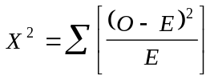

The Greek letter sigma (Σ) is used in statistical formulae to denote the sum of a series of numbers. Squaring a number (multiplying a number by itself) is a convenient way of turning negative numbers into positive numbers and is used in many statistical formulae for this purpose.

Under the null hypothesis there is a fixed probability of obtaining this particular chi-square value. If the probability of obtaining 179.52 under the null hypothesis is small then the null hypothesis is unlikely to be true and we would assume that there is an association between the use of poppers and HIV status. If the probability of obtaining 179.52 under the null hypothesis is large then the null hypothesis might be true and we would not assume that there is an association between the use of poppers and HIV status.

Chi-square, degrees of freedom, and p-values

Chi-squares, degrees of freedom, and p-values

The probability of observing a particular chi-square value is determined by the chi-square distribution. There is a different chi-square distribution for each size of table. A large chi-square is more likely to arise from a large table (i.e. a table with many cells) than from a small table (i.e. a table with few cells such as a 2-by-2 table). The more rows and columns in a table the larger the chi-square value is likely to be. This is because there are more cells in which the observed values are free to vary from the expected values. The number of cells in which the observed values are free to vary from the expected values is called the degrees of freedom. In this table:

HIVSTAT
POPPERS | 1 2 | Total
------------+-----------------------+------
1 | 348 ?? | 620
2 | ?? ?? | 413
------------+-----------------------+------
Total | 408 625 | 1033

knowing the value of one internal cell allows us to determine the values of the other three internal cells. This table has one degree of freedom. The degrees of freedom in a table is calculated using the formula:

df = (number of rows - 1) * (number of columns - 1)

The degrees of freedom in a 2-by-2 table are:

df = (number of rows - 1) * (number of columns - 1) = (2 - 1) * (2 - 1) = 1

The chart on the next page shows the probability of observing chi-square values at different degrees of freedom. Look at the chi-square distribution for one degree of freedom. The probability of getting a chi-square value of 179.52 from a 2-by-2 table is very small. This probability is referred to as the p-value and is the probability that the observed association arose by chance. If we refer to the chi-square distribution with one degree of freedom in a set of statistical tables we obtain a p-value of less than 0.0001. The probability that the observed association arose by chance is less than 0.0001 (i.e. less than one in ten thousand). It is unlikely that the observed association arose by chance. It is reasonable to reject the null hypothesis of no association. It is generally considered safe to reject the null hypothesis with a p-value less than 0.05 (i.e. less than one in twenty). When the p-value is less than 0.05, the association between the row and column variables is said to be statistically significant. Small p-values are more significant than large p-values: a p-value of 0.001 is more significant than a p-value of 0.01.

There are several chi-square tests. The one described here is called Pearson's chi-square. Another test of association is Yates' corrected chi-square which uses the same formula but includes a correction factor and is used for two-by two tables. Yates' corrected chi-square is always slightly smaller than Pearson's chi-square and will always yields a slightly larger p-value. Most statisticians prefer Yates’ corrected chi-square because it is more conservative and less likely to yield a significant p-value when the null hypothesis is true. Another test of association is Fisher’s exact test. This is based on a distribution called the hypergeometric distribution and is not a chi-square test. Chi-square tests can yield misleading results when expected numbers are small. Fisher's exact test is more robust and can yield reliable results with small expected numbers. Fisher’s exact test should be used instead of a chi-square test when any of the cells in the 2-by-2 table has an expected value of less than five. ANALYSIS will report Pearson's chi-square for all tables and Yate's corrected chi-square for two-by-two tables. If an expected value in a two-by-two table is less than five then ANALYSIS will also report Fisher's exact test. There are two p-values associated with Fisher’s exact test: the one-tailed p-value and the two-tailed p-value. The one-tailed p-value is appropriate when we are interested in examining the effects of exposure variables in one direction only (e.g. do they increase the risk of illness?). In other types of studies we are usually testing for any association and would use a two-tailed p-value. If in doubt you should use the two-tailed p-value. The one-tailed p-value would be appropriate here because we are interested in examining the effects of an exposure variable in one direction only (i.e. does use of poppers increase the probability of being HIV-positive?).
Chi-squares, degrees of freedom, and p-values

The chi-square distribution

The chart below shows the probability of observing chi-square values at three different degrees of freedom:

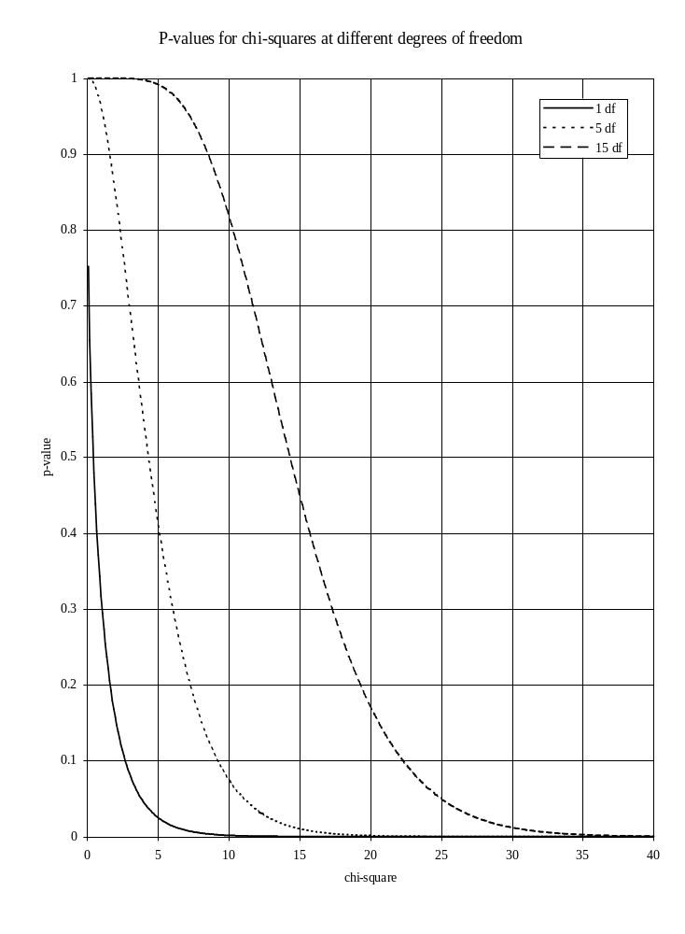
The value of 179.52 on the x-axis (chi-square on x-axis) is off the chart, but you can still estimate the probability of calculating this value from data in a 2-by-2 table (p-value on y-axis) if the null hypothesis were true.

Two-by-two tables

Confidence intervals and significance tests

Both confidence intervals and significance tests can be used to test for an association between exposure and outcome variables. They are related approaches to the same problem. If the 95% confidence interval for a relative risk does not include one then the chi-square will have a p-value of less than 0.05 (5%). The confidence interval (or estimation) approach is preferred as it provides an estimate of the magnitude and direction of the effect and the variability of the estimate. The statistical significance testing approach only indicates the consistency of the data with the null hypothesis and provides no estimate of the magnitude or direction of the effect. Both approaches are influenced by sample size. Large numbers in cells will yield large chi-square values. Consider using a chi-square test to establish whether an association exists between SMOKER and being a HIVSTAT:

HIVSTAT
SMOKER | 1 2 | Total
------------+-----------------------+------
1 | 187 242 | 429
2 | 221 382 | 603
------------+-----------------------+------
Total | 408 624 | 1032

This table yields a chi-square statistic of 5.05 with a p-value of 0.025. If we assume that the sample size of the study had been three times larger (by multiplying all cells in the table by three) the following table would result:

HIVSTAT
SMOKER | 1 2 | Total
------------+-----------------------+------
1 | 561 726 | 1287
2 | 663 1146 | 1809
------------+-----------------------+------
Total | 1224 1872 | 3096

which yields a chi-square statistic of 15.15 (3 * 5.05) with a P-value of 0.0000993. The chi-square value has been influenced by the sample size. If we perform the same experiment but calculate the relative risk and confidence interval we get the following results:

RISK RATIO(RR)(Outcome:HIVSTAT=1; Exposure:SMOKER=1) 1.19
95% confidence limits for RR 1.02 < RR < 1.38

for the original table and:

RISK RATIO(RR)(Outcome:HIVSTAT=1; Exposure:SMOKER=1) 1.19
95% confidence limits for RR 1.09 < RR < 1.30

for the table with increased sample size. The point estimate is the same but the confidence interval is narrower. Increasing the sample size will give a smaller p-value and a narrower confidence interval.

You should never multiply the numbers in a 2-by-2 table to get a significant p-value or a narrower confidence interval. The only valid method of increasing the sample size is to collect more data!

Two-by-two tables

An example of ANALYSIS output

The following table was produced using the command TABLES POPPERS HIVSTAT. Important information has been highlighted:

HIVSTAT
POPPERS | 1 2 | Total
------------+-----------------------+------
1 | 348 272 | 620
2 | 60 353 | 413
------------+-----------------------+------
Total | 408 625 | 1033

Single Table Analysis

Odds ratio 7.53 <- Odds Ratio
Cornfield 95% confidence limits for OR 5.41 < OR < 10.50 <- Confidence Limits
Maximum likelihood estimate of OR (MLE) 7.51
Exact 95% confidence limits for MLE 5.44 < OR < 10.50
Exact 95% Mid-P limits for MLE 5.50 < OR < 10.37
Probability of MLE >= 7.51 if population OR = 1.0 0.00000000

RISK RATIO(RR)(Outcome:HIVSTAT=1; Exposure:POPPERS=1) 3.86 <- Relative Risk
95% confidence limits for RR 3.03 < RR < 4.93 <- Confidence Limits
Ignore risk ratio if case control study

Chi-Squares P-values
----------- --------
Uncorrected: 179.52 0.00000000 <--- <- Chi-square/p-value
Mantel-Haenszel: 179.35 0.00000000 <---
Yates corrected: 177.78 0.00000000 <--- <- Corrected values

Notice that ANALYSIS produces three chi-square measures and p-values. With two-by-two tables you may quote either the uncorrected or corrected values. The corrected value is preferred as it is more conservative and less prone to error.

Summary of measures introduced

The table below summarises the measures of effect and association introduced so far:

Measure | Value | Interpretation | Notes
Relative risk | < 1 | decrease in risk | not valid for case-control studies
 | = 1 | no effect
 | > 1 | increase in risk
Odds ratio | < 1 | decrease in risk | valid for case-control studies
 | = 1 | no effect
 | > 1 | increase in risk
Confidence interval | includes 1 | observed association could be due to random variation | applies to relative risk / odds ratio
 | excludes 1 | observed association unlikely to be due to random variation
P-value | > 0.050 | observed association could be due to random variation | applies to test statistic
 | < 0.050 | observed association unlikely to be due to random variation
 | < 0.010 | observed association very unlikely to be due to random variation
 | < 0.001 | observed association extremely unlikely to be due to random variation

Contingency tables

Tables larger than two-by-two

In tables larger than two-by-two it is difficult to calculate risk measures and so we must rely on significance testing. Issue the command:

tables race hivstat

to investigate the association between race and HIV status. The following table is produced:

HIVSTAT
RACE | 1 2 | Total
-----------+-------------+------
1 | 354 537 | 891
2 | 22 30 | 52
3 | 20 29 | 49
4 | 8 26 | 34
-----------+-------------+------
Total | 404 622 | 1026

Chi square = 3.85 <- Chi-square
Degrees of freedom = 3
p value = 0.27773826 <- p-value

If you examine the statistics that follow the table you will see that RACE does not appear to be associated with being HIVSTAT. The p-value that ANALYSIS reports for the chi-square statistic is 0.27773826 (i.e. p > 0.05) indicating that any differences between the values we observe in the table and the values we would expect if the null hypothesis of no association were true could be due to random variation.

You can get a better understanding of what is going on in this table if you issue the command:

set percents = on

before issuing the TABLES command and examining the row percentages:

HIVSTAT
RACE | 1 2 | Total
-----------+-------------+------
1 | 354 537 | 891 <- Counts
> 39.7% 60.3% > 86.8% <- Row percentages
| 87.6% 86.3% | <- Column percentages
2 | 22 30 | 52
> 42.3% 57.7% > 5.1%
| 5.4% 4.8% |
3 | 20 29 | 49
> 40.8% 59.2% > 4.8%
| 5.0% 4.7% |
4 | 8 26 | 34
> 23.5% 76.5% > 3.3%
| 2.0% 4.2% |
-----------+-------------+------
Total | 404 622 | 1026
| 39.4% 60.6% |

If you examine the row percentages, you will see that the proportion of HIV-positives for are similar for all values of the RACE variable. In this case HIVSTAT is said to be unrelated to RACE (i.e. HIVSTAT and RACE are not associated with each other). This observation can be quantified with the chi-square and above p-value.
Writing-up

What you should quote in reports

If you are using two-by-two tables to analyse your data you should quote the relative risk (or odds ratio) and the associated confidence interval. Remember to specify the confidence level as this can vary. A typical quote might be:

'We found popper use within the past two years to be associated with HIV infection (RR = 3.86, 95% C.I. 3.03 - 4.93).'

Some journals may require you to quote a chi-square and p-value. A typical quote might be:

'We found popper use within the past two years to be associated with HIV infection (Yates chi-square = 177.78, p < 0.0001).'

Some may want both:

'We found popper use within the past two years to be associated with HIV infection (RR = 3.86, 95% C.I. 3.03 - 4.93, Yates chi-square = 177.78, p < 0.0001).'

If you are using contingency tables larger than two-by-two you should quote the chi-square, degrees of freedom, and the associated p-value. A typical quote might be:

'We found no association between race and HIV infection (chi-square = 3.85, df = 3, p = 0.28).'

When quoting p-values it is conventional to quote the calculated value if it is above p = 0.05 or the threshold value (P < 0.05, p < 0.01, p < 0.001, p < 0.0001) if it is below the threshold value (i.e. for significant results).

Practical exercise

Variables and variable names

For a full explanation of variables, their names, and their codes refer to the table on page 10.

Exercise 5 - Recoding variables and two-by-two tables

Use the RECODE or IF ... THEN commands to recode the CD4 variable into two groups ('1LOW' and '2NORMAL'). Use the lower quartile of the distribution of the CD4 variable for the '1LOW' group and the upper three quartiles for the ‘2NORMAL' group. You can find the quartiles of the distribution of the CD4 variable using the DESCRIBE or FREQ commands. Make sure that the cut-points you specify with the RECODE or IF … THEN commands are not ambiguous (i.e. ensure the two groups do not overlap).

Use the LIST or BROWSE command to check that the RECODE or IF ... THEN commands you used have worked correctly.

Use the TABLES command to investigate the association between your new variable and HIVSTAT.

Use the TABLES command to investigate the association between SEXPREF, SMOKER, and POPPERS and your new variable.
Tables with subsets of data

Selecting cases for ANALYSIS

With data from the San Francisco Men’s Health Study, it is possible to explore whether Blacks and Hispanics have different risks of being HIV-infected. The RACE variable records which group each individual case belongs to:

RACE | Freq Percent Cum.
------+-----------------------
1 | 897 86.6% 86.6%
2 | 52 5.0% 91.6%
3 | 52 5.0% 96.6%
4 | 35 3.4% 100.0%
------+-----------------------
Total | 1036 100.0%

Use the SELECT command to instruct analysis to ignore the data from the “white” (RACE = 1) and “other” (RACE = 4) individuals:

select race <> 1
select race <> 4

and use the TABLES command to investigate the association between RACE and HIVSTAT:

tables race hivstat

which produces the following two-by-two table:

HIVSTAT
RACE | 1 2 | Total
------------+-----------------------+------
2 | 22 30 | 52
3 | 20 29 | 49
------------+-----------------------+------
Total | 42 59 | 101

Single Table Analysis

Odds ratio 1.06
Cornfield 95% confidence limits for OR 0.44 < OR < 2.55
Maximum likelihood estimate of OR (MLE) 1.06
Exact 95% confidence limits for MLE 0.45 < OR < 2.53
Exact 95% Mid-P limits for MLE 0.48 < OR < 2.37
Probability of MLE >= 1.06 if population OR = 1.0 0.52005279

RISK RATIO(RR)(Outcome:HIVSTAT=1; Exposure:RACE=2) 1.04
95% confidence limits for RR 0.65 < RR < 1.65

Ignore risk ratio if case control study

Chi-Squares P-values
----------- --------

Uncorrected: 0.02 0.87920065
Mantel-Haenszel: 0.02 0.87979558
Yates corrected: 0.00 0.96012694

Note that the SELECT command has excluded those cases where RACE = 1 or RACE = 4 from the analysis (the ‘< >’ operator means ‘not equal to ...’).

Examine the relative risk and its associated confidence limits. The relative risk is greater than 1 indicating a higher risk of being HIV-infected for Hispanics than for Blacks. The confidence interval includes one indicating that the observed association (or increase in risk) is likely to be due to random variation. The p-value for Yates chi-square is 0.96 which also indicates that the observed association (or increase in risk) is likely to be due to random variation.

The data do not support the hypothesis that Blacks and Hispanics have different risks of being HIV-infected (RR = 1.06, 95% C.I. 0.65 - 1.65, Yates chi-square = 0.00, p = 0.96).
Practical exercise

Variables and variable names

For a full explanation of variables, their names, and their codes refer to the table on page 10.

Exercise 6 - Recoding, subsets, and two-by-two tables

Use the RECODE or IF ... THEN commands to recode the HIVLOAD variable into two groups ('1HIGH' and ‘2LOW’). Use the lower three quartiles of the distribution of this variable for the ‘2LOW' group and the upper quartile for the '1HIGH' group. You can find the quartiles of the distribution of a variable using the DESCRIBE or FREQ commands. Make sure that the cut-points you specify with the RECODE or IF … THEN commands are not ambiguous (i.e. ensure the two groups do not overlap).

Use the LIST or BROWSE command to check that the RECODE or IF ... THEN commands you used have worked correctly.

Use the TABLES command to investigate the association between RACE and your new variable. Does the evidence support the hypothesis that Blacks are at greater risk of high HIV load relative to Hispanics?

Categorical and continuous data

Recoding and information loss

So far we have been comparing groups and testing hypotheses using categorical data that we derived from continuous data. The problem with this approach is that when we collapse a continuous variable into groups we are losing information. Also, it is not always possible to set sensible threshold values that divide the data into groups. In such cases you will need to use analytical techniques that deal with continuous data. One technique that can be applied to such data is analysis of variance (also called ANOVA). This technique is used to test the null hypothesis that the several population means are equal.

If you haven’t already done so, clear the race selections you made earlier by typing:

select

At the top of the screen should be a message saying “All records selected.”

For the next analysis we will compare the “White” group to the “Non-white” group by combining “Hispanic,” “Black,” and “Other” into one category. To do this, type:

define white #
recode race to white 1=1 2,3,4=2

Now have a look at the mean HEIGHT for each category of the WHITE variable by issuing the command:

means height white /n

Ignore the lengthy statistical output and concentrate on the summary statistics for each group:

WHITE Obs Total Mean Variance Std Dev
1 892 158459 177.645 45.991 6.782
2 136 23720 174.412 56.229 7.499
Difference 3.233

WHITE Minimum 25%ile Median 75%ile Maximum Mode
1 160.000 173.000 178.000 183.000 196.000 178.000
2 160.000 168.000 175.000 180.000 193.000 173.000

Examine the summary statistics carefully and make sure that you can identify the number of observations, minimum, maximum, mean, standard deviation, median, and mode for each of the two groups. Another way of looking at the same data is to display it as a line chart. Issue the command:

line height white

and examine the resulting graph. You might like to group the HEIGHT variable to make the graph easier to read.

The ‘/n’ at the end of the means command:

means height white /n

instructs ANALYSIS not to display a table of HEIGHT by WHITE before displaying the summary statistics for each group. This table is often of little use.

Differences in means

Analysis of variance

With analysis of variance the variability of the data is split into two components:

1. Variability of the data within each group around the group mean

2. Variability of the means between groups

If HEIGHT doesn't vary much between individuals within the a WHITE group (e.g. white participants have similar heights, and non-white participants have similar heights) but the group means differ a great deal, there is evidence that the population means are not equal:

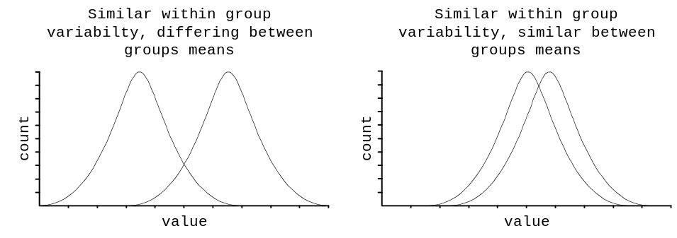
The variability within each group is called the within-groups sum of squares and is calculated as:

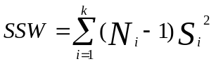

where Si² is the variance of group i about its mean, Ni is the number of cases in group i, and k is the number of groups . For us:

SSW = (892 - 1) * 45.991 + (136 - 1) * 56.229 = 48568.896

The variability of the group means is measured by the between-groups sum of squares and is calculated as:

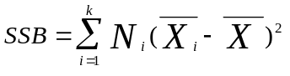

where 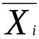 is the mean of group i and 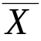is the overall mean. For our data:

SSB = 892 * (177.645 – 177.217)2 + 136 * (174.412 - 177.217)2 = 1233.451528

A test statistic is calculated as the ratio of the mean squares of these two numbers. The means squares are calculated by dividing each sum of squares figure by its degrees of freedom. The between-groups degrees of freedom is k-1 where k is the number of groups. The within-groups degrees of freedom is N - k where N is the number of cases in the entire sample. The ratio of these mean squares is called the F statistic:

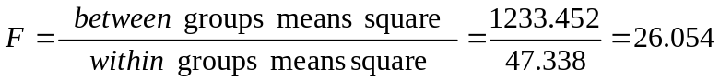

The p-value can be obtained by comparing the calculated F statistic against the F distribution (at k - 1 and N - k degrees of freedom) in a set of statistical tables. Fortunately ANALYSIS calculates the F statistic and the associated p-value for us.
ANOVA - worked example

A worked example of ANOVA calculations

The table below shows 20 values of HEIGHT for the WHITE group and 18 values of HEIGHT for the non-WHITE group:

WHITE | 193 | 180 | 178 | 188 | 183 | 185 | 178 | 183 | 183 | 180
 | 180 | 180 | 178 | 178 | 165 | 175 | 193 | 168 | 173 | 175
NON-WHITE | 178 | 173 | 168 | 165 | 168 | 173 | 180 | 163 | 163 | 173
 | 183 | 163 | 165 | 168 | 173 | 165 | 183 | 165

The means and variances for this data are:

Group | Mean | Variance
BOTH | 175.395 | 68.894
WHITE | 179.800 | 49.326
NON-WHITE | 170.500 | 46.618

The within groups sum of squares is:

SSW = (20 - 1) * 49.326 + (18 - 1) * 46.618 = 1729.700

The within group degrees of freedom is:

20 + 18 - 2 = 36

The within group mean square is:

1729.700 / 36 = 48.047

The between groups sum of squares is:

SSB = 20 * (179.800 – 175.395)2 + 18 * (170.500 – 175.395)2 = 819.379

The between group degrees of freedom is:

2 - 1 = 1

The between groups mean square is:

819.379 / 1 = 819.379

The ratio of the between groups mean square and the within groups mean square is the F statistic:

F = 819.379 / 48.047 = 17.054

The observed significance value or p-value can be obtained by comparing the calculated F statistic against an F distribution (at k - 1 and N - k degrees of freedom) in a set of statistical tables - in this example p < 0.05.

ANOVA in ANALYSIS

An example of ANALYSIS output

The command:

means height white /n

produces the following summary statistics and ANOVA table:

WHITE Obs Total Mean Variance Std Dev
1 892 158459 177.645 45.991 6.782
2 136 23720 174.412 56.229 7.499
Difference 3.233

WHITE Minimum 25%ile Median 75%ile Maximum Mode
1 160.000 173.000 178.000 183.000 196.000 178.000
2 160.000 168.000 175.000 180.000 193.000 173.000

ANOVA
(For normally distributed data only)

Variation SS df MS F statistic p-value
Between 1233.340 1 1233.340 26.054 0.000000 <- F-Statistic/p-value
Within 48569.285 1026 47.338
Total 49802.625 1027

Bartlett's test for homogeneity of variance
Bartlett's chi square = 2.481 deg freedom = 1 p-value = 0.115240

The variances are homogeneous with 95% confidence.
If samples are also normally distributed, ANOVA results can be used.

In this case the p-value is less than 0.0001 which is evidence that the observed difference in the means of the two groups is unlikely to have arisen by chance.

Issue the command:

means height white /n

and examine the output carefully making sure you can identify the F-statistic and its associated p-value.

What you should quote in reports

If you are using ANOVA techniques to analyse your data you should quote the means for each group together with the F-statistic, degrees of freedom, and p-value. A typical quote might be:

'The White and Non-white groups had differing mean heights (White mean = 177.645, Non-white mean = 174.412, F = 26.054, df = (1,1026), p < 0.0001)'

Practical exercise

Variables and variable names

For a full explanation of variables, their names, and their codes refer to the table on page 10.

Exercise 7 - Analysis of variance (ANOVA)

Use the MEANS command to test the null hypothesis that the means of the WEIGHT and AGE variables for White and Non-white study participants are the same.
Problems with ANOVA

What ANOVA assumes about your data

ANOVA is a fairly robust statistical test. This means that the test can be applied to a wide range of data without it reporting misleading values. ANOVA does, however, make several assumptions about data. These are:

1. The groups are independent of each other. This means that the groups should be mutually exclusive. In our data this means that we should not include the same individual in the White group and the Non-white group. You should not use ANOVA techniques with repeated measurements from the same subjects.

2. The variable being studied should be (more-or-less) normally distributed. A normal distribution is a symmetrical bell-shaped distribution where the mean, median, and mode are similar to each other:

3. The variable being studied should have similar variances (or standard deviations) for each group.

If any of these assumptions are violated then the ANOVA technique may produce unreliable results. You should always test these assumptions before placing any trust in the results of any ANOVA based analysis.
Testing the ANOVA assumptions

Examining the output

The following output was produced using the command MEANS HEIGHT WHITE:

MEANS of HEIGHT for each category of WHITE

WHITE Obs Total Mean Variance Std Dev
1 892 158459 177.645 45.991 6.782
2 136 23720 174.412 56.229 7.499
Difference 3.233

WHITE Minimum 25%ile Median 75%ile Maximum Mode
1 160.000 173.000 178.000 183.000 196.000 178.000
2 160.000 168.000 175.000 180.000 193.000 173.000

We can examine the assumption of normality by comparing the mean, mode and median within each group. If the data is normally distributed we would expect the mean, median, and mode to take similar values. In our data this is true for both groups. The assumption that the variances are equal can be tested by comparing the values in the variance column of the two groups. In our data the variances are quite similar. There is a formal statistical test that tests the hypothesis that the variances are equal. This is Bartlett's Test and is displayed below the ANOVA table by ANALYSIS:

Bartlett's test for homogeneity of variance
Bartlett's chi square = 2.481 deg freedom = 1 p-value = 0.115240

The variances are homogeneous with 95% confidence.
If samples are also normally distributed, ANOVA results can be used.

Bartlett's test confirms that the variances are similar enough for us to use the ANOVA technique.

You can also test the assumption of normality by examining a HISTOGRAM or LINE chart of the distribution of the variable under study. Here HEIGHT has been grouped to better show the underlying distribution:
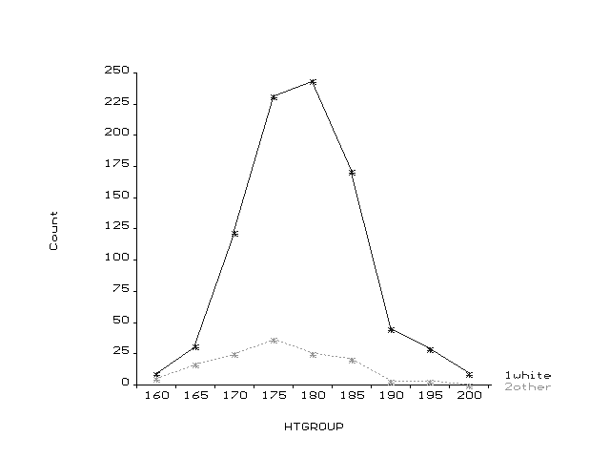

This also shows that the HEIGHT data in the both groups is approximately normally distributed. This means that it is valid to use the ANOVA technique to analyse our data.

Practical exercise

Variables and variable names

For a full explanation of variables, their names, and their codes refer to the table on page 10.

Exercise 8 - Testing the ANOVA assumptions

Use the MEANS command to test the ANOVA assumptions for WEIGHT and AGE grouped for the White and Non-white study participants. Test the ANOVA assumptions using the comparison of means, medians, modes, and standard deviations and with LINE charts or HISTOGRAMs. You may need to group these variables before producing LINE charts and HISTOGRAMs.
When ANOVA is unsuitable

It's a common problem

The assumption of normality is frequently violated. This is often a problem with data which are based on scores or counts. This data tends to be distributed so that most individuals have low scores, counts, or values and a few individuals have high scores, counts, or values. Such distributions are called skewed distributions. A distribution with many individuals with low values is called a positively skewed or skewed to the right distribution:

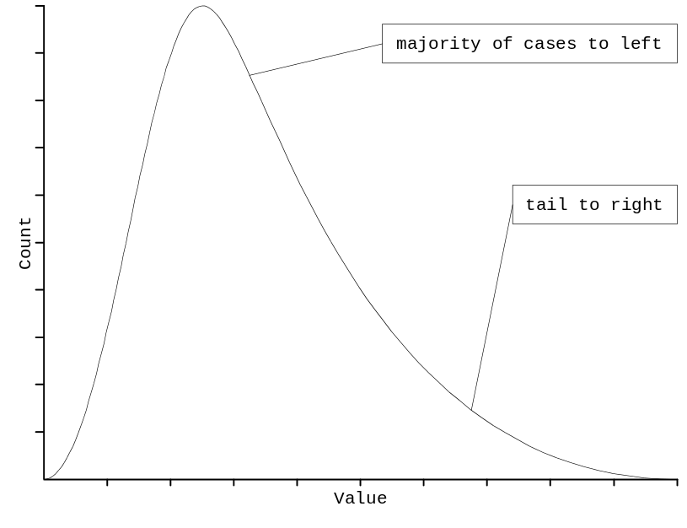
and is typical of biological measures such as triceps skin fold. A distribution with many individuals with high values is called a negatively skewed or skewed to the left distribution:

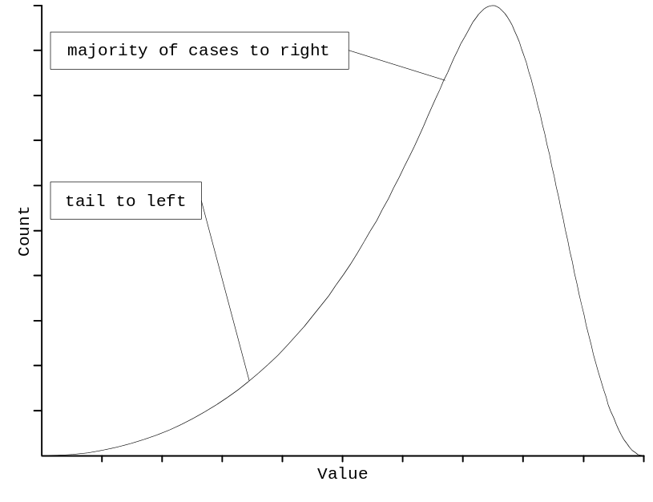
and is typical of biological measures such as gestation period. Both of these distribution types are common. With these types of distribution, the mean and standard deviation do not describe the population well and statistical techniques that rely on them (such as ANOVA) are not reliable.
What can be done?

Transforming the data

If the data do not fit the ANOVA assumptions we could attempt to change the data to make it more suitable. Changing the data in this way is called transforming the data and it is achieved by applying a simple mathematical formula to each data point. The table below shows the most useful transformations that can be applied to data that do not fit the ANOVA assumptions:

Problem | Severity / Nature | Transformation | Formula
Positively skewed | severe  moderate  slight | reciprocal  logarithmic  square root | -1/x  log(x)  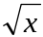
Negatively skewed | severe  moderate | cubic  square | x3  x2
Unequal variances | proportional to mean  proportional to the square of the mean  proportional to the square root of the mean | logarithmic  reciprocal  square root | log(x)  -1/x

For example, with a moderate positive (right) skew:

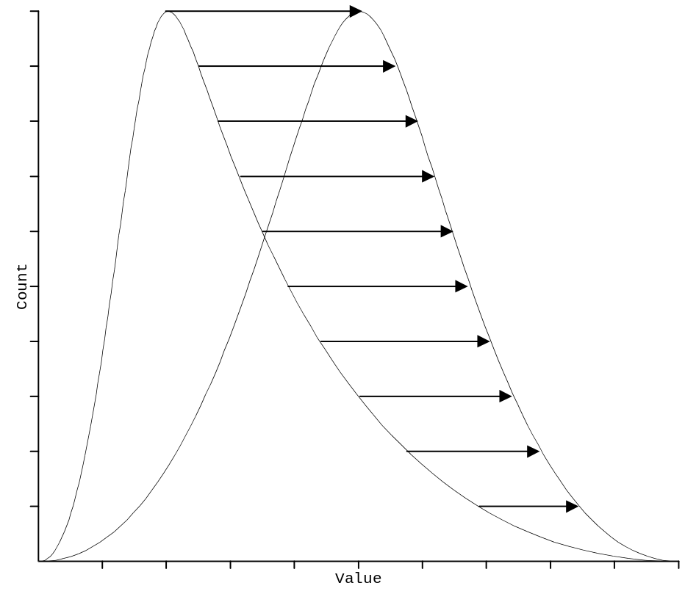
a transformation of the variable (such as a logarithmic transformation) will move the higher data values less than the lower data values bringing the distribution closer to the normal distribution.

The most commonly used transformation is the logarithmic transformation. Always try this transformation first as it will solve the majority of problems associated with non-normal data.
Checking the data

Checking the data for skew and unequal variance

Issue the command:

means npartner white

and examine the output carefully. The mean, median, and mode for each group are quite different from each other:

WHITE Obs Total Mean Variance Std Dev
1 895 35890 40.101 10005.390 100.027
2 138 2520 18.261 1524.895 39.050
Difference 21.840

WHITE Minimum 25%ile Median 75%ile Maximum Mode
1 0.000 1.000 10.000 30.000 998.000 0.000
2 0.000 0.000 4.000 16.000 300.000 0.000

The standard deviations in the two groups are also very different from each other. This is confirmed by Bartlett's test:
Bartlett's test for homogeneity of variance
Bartlett's chi square = 1.3E+02 deg freedom = 1 p-value = 0.000000

Bartlett's Test shows the variances in the samples to differ.
Use non-parametric results below rather than ANOVA.

Despite the problems of skew and unequal variance with this data, it may still be possible to use ANOVA techniques after applying a logarithmic transformation.

Transforming the data

Applying a logarithmic transformation

Create a new variable called LOGPART to hold the logarithm of the NPARTNER variable:

define logpart #.####

and assign a value to this variable:

logpart = log(npartner + 1)

The variable LOGPART now contains the logarithm of the NPARTNER variable. We need to add 1 to NPARTNER so that we do not try to take the logarithm of zero (a non-existent number). We would need to do the same if we were to use a reciprocal transformation as one divided by zero is an infinitely large number. Issue the commands:

select
select logpart <> . and white <> .
means logpart white /n

The first line clears any previous selections, and the second and third lines eliminate any cases for which LOGPART and WHITE are missing. You should do this before any analysis using two or more variables.

Examine the output carefully. The mean, median, and mode for each group are now more similar:

WHITE Obs Total Mean Variance Std Dev
1 895 891 0.996 0.559 0.747
2 138 106 0.770 0.430 0.656
Difference 0.226

WHITE Minimum 25%ile Median 75%ile Maximum Mode
1 0.000 0.301 1.041 1.491 3.000 0.000
2 0.000 0.000 0.699 1.230 2.479 0.000

The standard deviations in the two groups are also similar. Note that the p-value for Bartlett’s test is borderline at p=0.05.

Bartlett's test for homogeneity of variance
Bartlett's chi square = 3.796 deg freedom = 1 p-value = 0.051368

The variances are homogeneous with 95% confidence.
If samples are also normally distributed, ANOVA results can be used.

Despite the original problems of skew and unequal variance with this data, ANOVA techniques may still be used after applying a logarithmic transformation. However, since p is very close to 0.05, we may still want to use the non-parametric Kruskal-Wallis (Wilcoxon-Mann-Whitney).
ANOVA and transformed data

What is the antilogarithm of the mean of the logarithms?

We have tried to transform the data to meet the assumptions of the ANOVA technique. If the assumption of equal variance had been met, we could have used this new transformed data to test our hypothesis. As a demonstration, issue the command:

means logpart white /n

which produces the following output:

WHITE Obs Total Mean Variance Std Dev
1 895 891 0.996 0.559 0.747
2 138 106 0.770 0.430 0.656
Difference 0.226

WHITE Minimum 25%ile Median 75%ile Maximum Mode
1 0.000 0.301 1.041 1.491 3.000 0.000
2 0.000 0.000 0.699 1.230 2.479 0.000

ANOVA
(For normally distributed data only)

Variation SS df MS F statistic p-value t-value
Between 6.097 1 6.097 11.259 0.000821 3.355423
Within 558.281 1031 0.541
Total 564.378 1032

We are working with the logarithmically transformed data. The summary measures are for this data. To get back to sensible values we need to use a calculator (or a set of log tables) to calculate the antilogarithms of the quoted values. For the White group the ‘average’ number of partners is 10^{0.996} = 9.908, and for the Non-white group it is 100.770 = 5.888. These values are different from the arithmetic mean of the untransformed data. They are known as geometric means. If you transform your data in this way make sure that you explicitly state that you are using geometric means in reports and papers.

What you should quote in reports

If you are using ANOVA techniques to analyse your data and have applied a logarithmic transformation to your data you should quote the geometric means for each group together with the F-statistic, degrees of freedom, and p-value. A typical quote might be:

'The White study participants had a higher geometric mean numbers of partners compared to Non-whites (White = 9.908, Non-white = 5.888, F = 11.259, df = 1, P < 0.001)'

Can't transform! Won't transform!

Difficult distributions

Sometime when you try to transform your data it just won't approach normality. This is often the case with distributions such as uniform distributions:

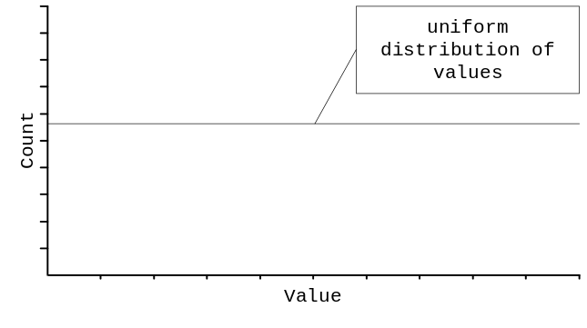

which are common in disease surveillance (i.e. a disease with no seasonal variation), multimodal distributions:

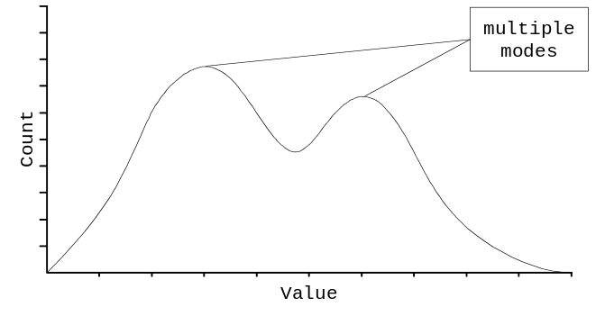

which are common biological distributions or when two groups are being (inappropriately) analysed together (e.g. hormone levels in mixed sex groups), or J-Shaped (very heavily skewed) distributions:

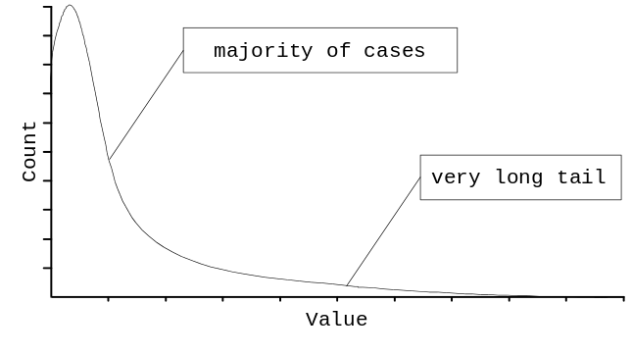
which are typical of survival times (e.g. AIDS diagnosis progressing to death) or counts (e.g. of parasites). A right skew is shown here but J-shaped distributions may also be skewed to the left. These extreme degrees of skew may be difficult to correct using transformations.

ANOVA techniques do not produce reliable results with these sorts of distribution because the parameters used in its calculation (means and variances) do not accurately reflect the distribution of the data.
Another problem with ANOVA

ANOVA and small datasets or small group sizes

All statistical tests require an adequate sample size if results are to be generalised from sample to population. ANOVA techniques require an adequate sample size in each strata. This means that there must be a sufficient number of cases in the White and Non-white groups. A sufficient number is usually taken to mean more than twenty (20) cases in this context but this really depends on the magnitude of difference that it is important to be able to detect. This is the final assumption that needs to be met if ANOVA results are to be trusted. Data that do not meet this assumption are called sparse data.

Non-parametric statistics

Non-parametric statistics are a set of statistical methods that make fewer assumptions about the distribution of data. They are called non-parametric because they do not assume that data can be described by a small number of parameters such as the mean and standard deviation which completely describes the normal distribution. They may also be used reliably with small sample / group sizes.

There are problems with using non-parametric techniques. Often, no parameters (e.g. mean and standard deviation) are estimated so it can be difficult to estimate the strength and direction of an effect or calculate confidence intervals. There are no reliable methods for calculating sample sizes for use with non-parametric statistics. Non-parametric statistics are also conservative. This means that they may falsely attribute small (but real) differences in the data to random variation.

Parametric techniques (such as ANOVA) are preferred to non-parametric techniques when the data meets the required assumptions.

Non-parametric statistics In ANALYSIS

ANALYSIS performs two non-parametric tests as part of the MEANS command. These are the Wilcoxon Rank-Sum Test (a.k.a. Mann-Whitney U-Test) and the Krustall-Wallis Test. Which test is performed depends on the number of groups being analysed. The Wilcoxon Rank-Sum Test is performed for two groups and the Kruskal-Wallis Test if there are more than two groups. Both test the hypothesis that the sample medians are equal.
Differences in medians

A worked example of the Wilcoxon Rank-Sum Test

This section presents a worked example of how the Wilcoxon Rank-Sum Test is calculated. As demonstration data we will use HEIGHT values from five White study participants and six Non-white study participants. These data are shown below:

WHITE | NONWHITE
193 | 178
168 | 163
178 | 173
170 | 168
180 | 185
 | 183

The data from both groups is combined, sorted, and given a rank (1 for the lowest value, 2 for the next lowest, and so on). It there are any ties (more than one value the same) the average rank is assigned to each observation:

WHITE | Ranks |  |  | NON-WHITE
 |  |  | 1.0 |  | 163
168 |  | 2.5 | 2.5 |  | 168
170 |  | 4.0
 |  |  | 5.0 |  | 173
178 |  | 6.5 | 6.5 |  | 178
180 |  | 8.0
 |  |  | 9.0 |  | 183
 |  |  | 10.0 |  | 185
193 |  | 11.0
 |  | 32.0

The ranks of the observations in the group with the smallest sample size (in this case the White group) are summed to produce a statistic called the W-Statistic or the sum of the ranks:

W = 2.5 + 4 + 6.5 + 8 + 11 = 32

On the basis of the null hypothesis that the distributions of ranks in both groups are the same, the distribution of the W statistic can be calculated and a p-value for the test can be derived from statistical tables. Fortunately ANALYSIS performs all of these calculations for us.

Note that with groups that have an even number of cases the median is calculated as the mean of the middle pair of cases. In this example, the median HEIGHT for the Non-white group is:

(173 + 178) / 2 = 175.5

Non-parametric tests in ANALYSIS

An example of ANALYSIS output

The following table was produced using the command MEANS NPARTNER WHITE /N. Important information has been highlighted:

WHITE Obs Total Mean Variance Std Dev
1 895 35890 40.101 10005.390 100.027
2 138 2520 18.261 1524.895 39.050
Difference 21.840

WHITE Minimum 25%ile Median 75%ile Maximum Mode
1 0.000 1.000 10.000 30.000 998.000 0.000
2 0.000 0.000 4.000 16.000 300.000 0.000

ANOVA
(For normally distributed data only)

Variation SS df MS F statistic p-value t-value
Between 57028.862 1 57028.862 6.423 0.011411 2.534415
Within 9153729.558 1031 8878.496
Total 9210758.420 1032

Bartlett's test for homogeneity of variance
Bartlett's chi square = 1.3E+02 deg freedom = 1 p-value = 0.000000

Bartlett's Test shows the variances in the samples to differ.
Use non-parametric results below rather than ANOVA.

Mann-Whitney or Wilcoxon Two-Sample Test (Kruskal-Wallis test for two groups)

Kruskal-Wallis H (equivalent to Chi square) = 11.376
Degrees of freedom = 1
p value = 0.000744

What you should quote in reports

If you are using non-parametric techniques such as the Wilcoxon Rank-Sum test to analyse your data you should quote the median for each group together with the name of the test used, the test statistic (e.g. W or Kruskal-Wallis H), the degrees of freedom, and p-value. A typical quote might be:

'The White study participants had more male sexual partners in the previous two years than the Non-white study participants (Kruskal-Wallis H, White median = 10.0, Non-white median = 4.0, chi-square = 11.376, df = 1, p < 0.001)'

Non-parametric tests and group size

Non-parametric techniques are better at dealing with sparse data than parametric techniques such as ANOVA. The non-parametric tests presented here will work reliably with group sizes of five or more.

Practical exercise

Variables and variable names

For a full explanation of variables, their names, and their codes refer to the table on page 10 or on the inside back cover of this book.

Exercise 9 - Doing it!

Use the techniques and commands presented thus far to test the hypotheses that:

1. Whites have a higher number of male sexual partners than Non-whites.

2. Higher educational status is associated with a lower CD4 count.

Two continuous variables

Working with different variable types

We have used techniques to analyse data of two different types:

Type | Description
Qualitative/  Categorical Data | Cases belong to a defined category or group such as RACE, EDUCational status, or SEXPREF. A particularly common type of categorical variable is a binary categorical variable where cases can belong to one of two alternative groups. The variables SEXPREF and SMOKER are examples of binary categorical variables in the San Francisco Men’s Health Study dataset.
Qualitative/ Numerical Data | Unmodified numerical measures. There are two types of numeric data. Discrete data is limited to discrete integers. A count of cases over time would be a discrete variable. Continuous data is measured on a continuous scale. Examples are height, weight, and blood pressure.

The statistical technique we use to analyse the data depends upon the types of data that we need to analyse:

1st Variable | 2nd Variable | Technique
Categorical | Categorical | Relative risks and confidence intervals (two-by-two tables)  Odds ratios and confidence intervals (two-by-two tables)  Chi-square statistic and p-values (contingency tables)  Fisher's Exact Test (two-by-two tables)
Continuous | Categorical | ANOVA (normally distributed data only)  Wilcoxon rank-sum test (non-normal or sparse data)  Kruskal-Wallis test (non-normal or sparse data)

As you would expect, there are statistical techniques for analysing data that is stored as two continuous variables. These techniques are known as correlation and regression.

Why use correlation and regression analysis?

Instead of worrying about new techniques we could stick to what we already know. When faced with the need to analyse two continuous variables we could recode one or both of the variables into groups and perform a contingency table analysis or use ANOVA (or non-parametric equivalent) techniques. The problems with this approach are:

1. When we recode data we are losing a lot of information. Recoded data often hides the variability of the data and can lead us into making unwarranted assertions about our data.

2. The choice of cut-points for group membership is often arbitrary. The choice of cut-point can make a difference to the results of any analysis.

To avoid these problems it is best to use techniques that can cope with the raw continuous data.
Examining associations

Using scatter plots to examine associations

The chart below shows a scatter plot of the HEIGHT and WEIGHT variables for each case:
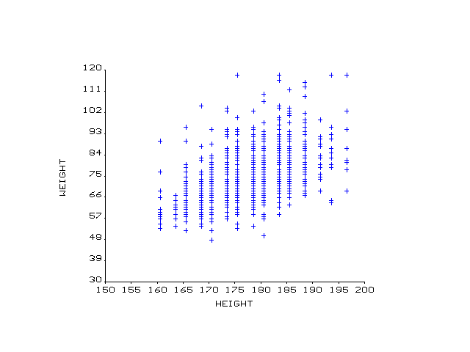

There appears to be an association between HEIGHT and WEIGHT. It is a positive association because as HEIGHT increases so does WEIGHT. The relationship is also called linear because the observed points cluster (more or less) around a straight line:
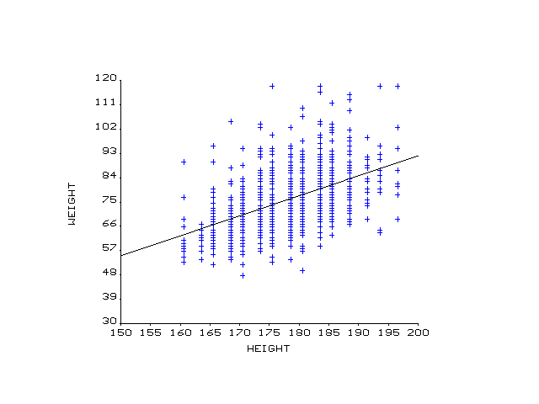

A scatter plot is the first step in studying the association between two continuous variables.
The strength of an association

Assessing the strength of an association

The strength of an association can be measured by calculating the Pearson correlation coefficient:

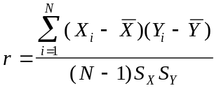

where N is the number of cases and SX and SY are the standard deviations of the two variables. The absolute value of r is an indication of the strength of the linear relationship.

The largest possible absolute value (the value regardless of sign) of r is one (1). This only occurs when all points fall upon a straight line.

When the line has a positive slope (i.e. y increases as x increases) the value of r is positive and when the line has a negative slope (i.e. y decreases as x increases) the value of r is negative:

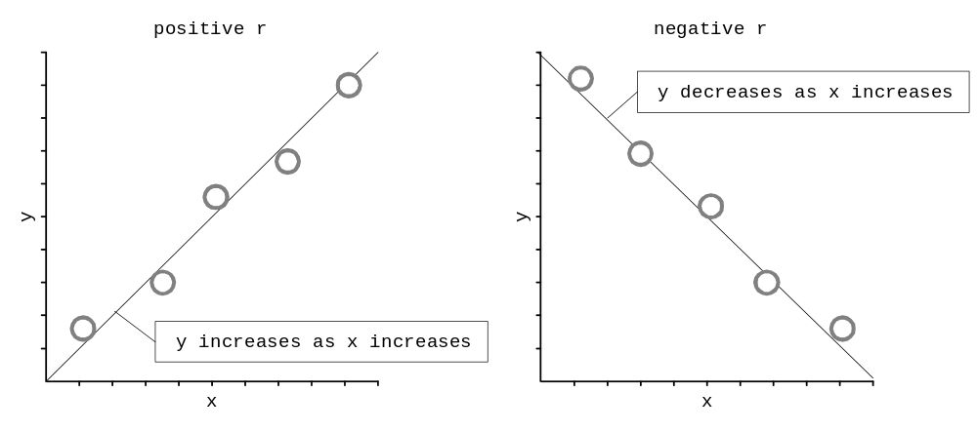

A value of zero (0) indicates no linear association.

Note that the calculation of r uses means and standard deviations and therefore requires that the distribution of both variables are approximately normal. You may need to transform one or both variables to meet this assumption (see pages 79 - 80).
Non-linear associations

The correlation coefficient and non-linear associations

You should note that Pearson correlation coefficient measures the strength of a linear association. It is possible to have a very strong association between two variables but a very small correlation coefficient. The chart below shows such a relationship:

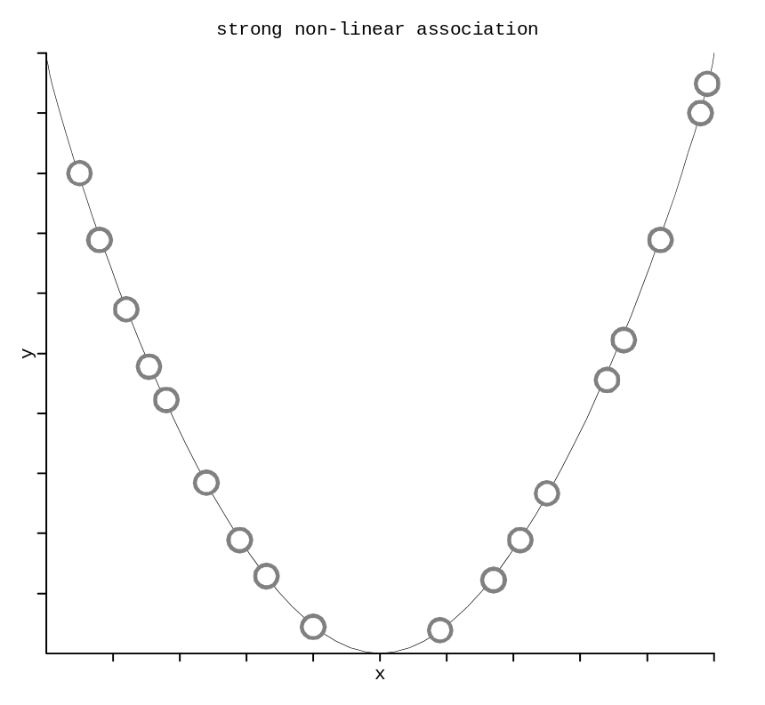

which yields a small Pearson correlation coefficient (r = 0.2). In this case it is not appropriate to measure the strength of association using the Pearson correlation coefficient - other techniques (which are not covered in this book) must be used. The Pearson correlation coefficient must only be used to assess the strength of a linear (as in straight line) association.

Because the correlation coefficient only tests the strength of a linear association, it is important to examine the nature of the association using scatter plots before calculating the correlation coefficient. If a strong association is observed but it is non-linear (i.e. cannot be well summarised using a straight line) then it may be possible to transform one or both of the variables to arrive at a more linear (straight line) association.

The calculation of the Pearson correlation coefficient is complicated and best left to purpose designed computer programs such as ANALYSIS.

Transformation and non-linear associations

Why transform data?

Transformation can also be useful when using correlation and regression analysis. You would apply a transformation to one or both variables in order to:

- Make a skewed distribution more symmetrical (i.e. make a skewed variable more normal).

- Make the variances (standard deviations) similar.

- Make an association more linear.

The first two applications have already been covered (see pages 65 - 70). All applications are important but, with correlation and regression analysis, the goal of making an association more linear is the most important.

How transformation can straighten an association

You can usually make an association more linear by applying a transformation to one of the variables. In this situation:

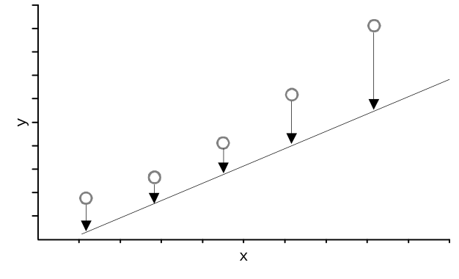
a transformation of the y-variable (such as a logarithmic or square-root transformation) will move the higher y data values more than the lower y data values bringing the y data values closer to a straight line. A similar effect might be obtained by applying a transformation to the x-variable. In this situation:

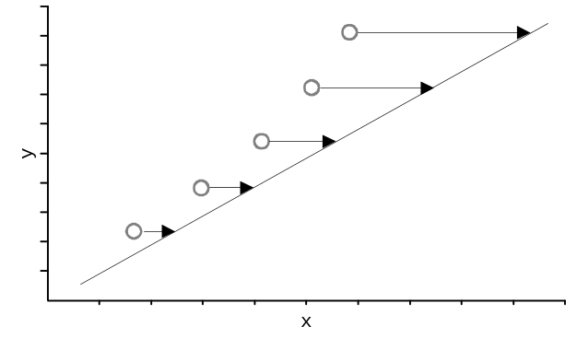
a transformation of the x-variable (such as squaring the x-variable) will move the higher x data values more than the lower x data values bringing the x data values closer to a straight line.

Which variable? Which Transformation?

Which variable should be transformed?

It is not particularly important which variable you choose to transform. Your choice should be guided by the three goals of transformation:

- Make a skewed distribution more symmetrical (i.e. make a skewed variable more normal).

- Make the variances (standard deviations) similar.

- Make an association more linear.

Sometimes you will need to transform only one variable (either x or y) or both variables to achieve these goals. You will need to experiment with different transformations of the two variables to achieve these goals. You should bear in mind that the third aim (to make an association more linear) can only be performed on associations where one variable increases (or decreases) as the other variable increases. In situations where a variable first decreases (or increases) and then increases (or decreases), it will not be possible to make the association linear.

Guidelines for transformation

There are four types of non-linear associations that respond well to transformation. These are:

Association Type | Transform X Only | Transform Y Only
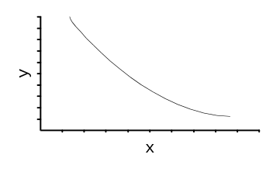 | 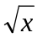  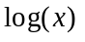  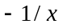  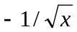 | 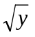  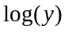  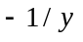  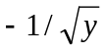
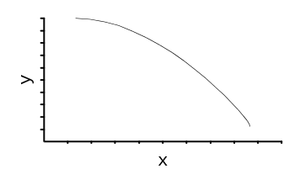 | 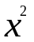  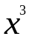 | 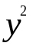  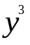
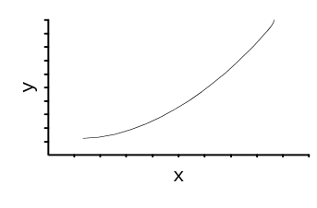
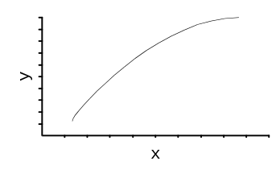

The sample transformations may not apply if both the x-variable and the y-variable are to be transformed.
Scatter plots and correlation coefficients

Producing scatter plots and correlation coefficients in ANALYSIS

Start ANALYSIS again and instruct ANALYSIS to read the San Francisco Men’s Health Study dataset by typing:

read sfmhshiv.rec

Examine the relationship between the HEIGHT and WEIGHT variables with the command:

scatter height weight

You can instruct ANALYSIS to draw the best-fit straight line by specifying the ‘/r’ option to the SCATTER command:

scatter height weight /r

You can instruct ANALYSIS to calculate the Pearson correlation coefficient with the command:

regress weight = height

ANALYSIS displays the Pearson correlation coefficient:

Correlation coefficient: r = 0.47 <- correlation coefficient
r^2 = 0.22
95% confidence limits: 0.16 < r^2 < 0.28

You may also have noticed that ANALYSIS calculated another measure called r^2 (r-squared) and 95% confidence limits. This is the square of the correlation coefficient and is called the coefficient of determination: This is a measure of how well the data corresponds to the best-fit straight line:

Correlation coefficient: r = 0.47
r^2 = 0.22 <- coefficient of determination
95% confidence limits: 0.16 < r^2 < 0.28 <- confidence limits

To determine the confidence limits for the Pearson correlation coefficient, take the square root of the confidence limits for r^2. The interpretation of the confidence limits is similar to using confidence limits for relative risks and odds ratios. Remember that r must lie between -1 and +1 and that a value of r = 0 indicates no linear association.

The coefficient of determination is sometimes interpreted as how much of the variability in the y-variable (e.g. WEIGHT) can be ‘explained’ by the variability in the x-variable (e.g. HEIGHT) and is expressed as a proportion (e.g. r^2 = 0.22 or 22%).

Note that the order of the variables for the SCATTER and REGRESS commands are reversed. The SCATTER command uses the form:

scatter x-yariable y-variable

and the REGRESS command uses the form:

regress y-variable = x-variable

In correlation and regression analysis the y-variable is called the response or dependant variable (this is analogous to the outcome variable in two-by-two table analysis) and the x-variable is called the explanatory or independent variable (this is analogous to the exposure variable in two-by-two table analysis). Before using these techniques you should be clear which variable is dependant and which is independent. The choice does not effect the correlation coefficient but does effect other regression statistics. In practice, it may be difficult to decide which is which. In this example, we are assuming that the WEIGHT of an individual is dependent upon (explained by) his HEIGHT.
Interpreting the correlation coefficient

What different values of the correlation coefficient mean

Interpretation of the correlation coefficient is not straightforward. Strengths of linear association vary depending on the field of study. What is considered a strong association in one field may be considered weak in another. The only really useful guide to interpreting the correlation coefficient is a thorough literature review of the field of study.

In general terms, a correlation coefficient that is close to zero indicates no linear association and a correlation coefficient that is close to one (or minus one) indicates a linear association. The table below shows general guideline values for assessing the strength of a linear association but it must be stressed that the correct interpretation depends upon the field of study:

Range of correlation coefficient | Interpretion
-1.0 to -0.8 | strong negative linear association
-0.8 to -0.5 | moderate negative linear association
-0.5 to -0.3 | weak negative linear association
-0.3 to +0.3 | no linear association
+0.3 to +0.5 | weak positive linear association
+0.5 to +0.8 | moderate positive linear association
+0.8 to +1.0 | strong positive linear association

Examine the correlation coefficient (and its confidence limits) for the association between the HEIGHT and WEIGHT variables:

Correlation coefficient: r = 0.47 <- correlation coefficient
r^2 = 0.22
95% confidence limits: 0.16 < r^2 < 0.28 <- confidence limits

In this case, the correlation coefficient is 0.47 with 95% confidence limits of 0.40 - 0.53 (these are calculated by taking the square root of the confidence interval for r^2 reported by ANALYSIS). If you compare these numbers with the guideline values in the table, you should see that there is a weak to moderate positive linear association between the two variables.

The interpretation of the confidence limits for the correlation coefficient is similar to that used with the relative risk or odds ratio except that zero is the null value. A confidence interval that includes zero indicates that the observed association may be due to random variation. In our example, as the confidence interval does not include 0, there does appear to be a relationship between height and weight.

The regression line

Summarising associations with straight lines

If there is a linear association between two variables you can use a straight line to summarise the data (in the same way as you can use the mean and standard deviation to summarise a single normally distributed continuous variable). When the correlation coefficient (r) is +1 or -1 the line that best summarises the data is the line that passes through all observations:

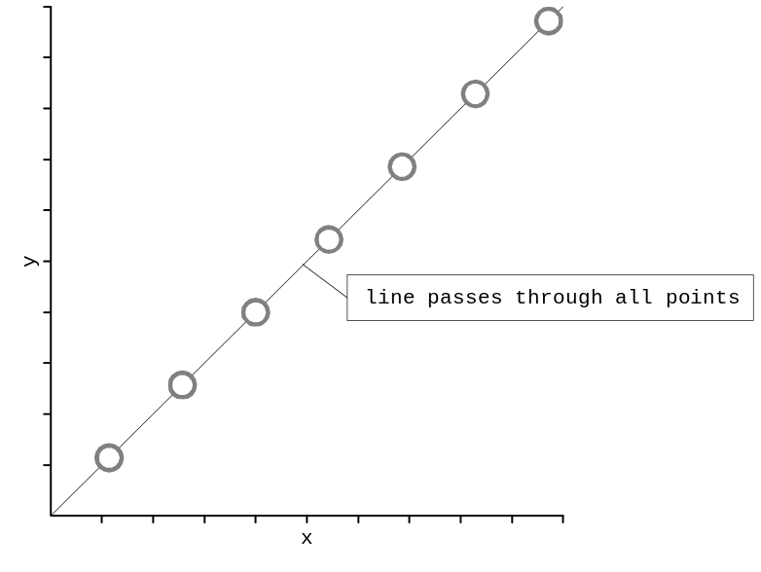

but when the variables are less strongly correlated there are many possible lines that could be chosen to represent the data:

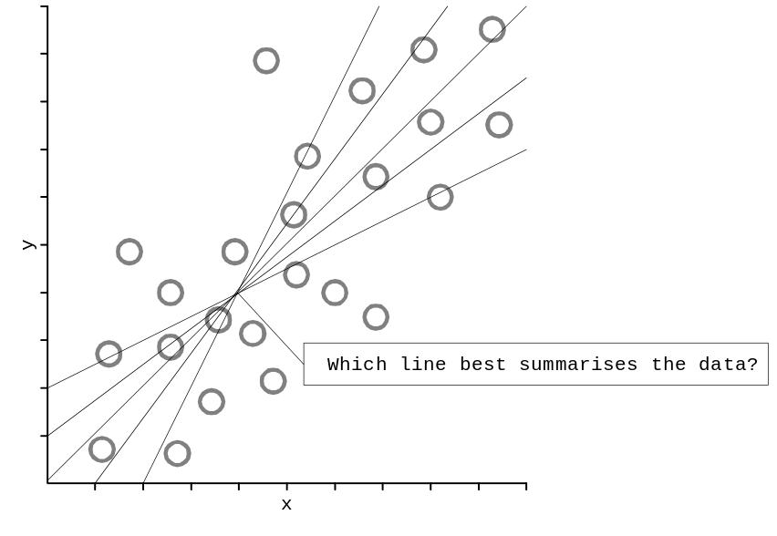

The most common method of fitting a line to data is the methods of least squares. This methods results in a line that minimises the sum of the squared vertical distances from the data point to the line.

The regression line

The method of least squares

Any straight line drawn on a chart can be represented by the equation:

y = α + βx

where y is the response (or dependant) variable and x is the explanatory (or independent variable). The equation tells us how these two variables are related. The term α is the intercept, the point at which the line cuts the y-axis (i.e. the value of y when x = 0). The term β is the slope of the line, the increase (or decrease) in y per unit increase in x:

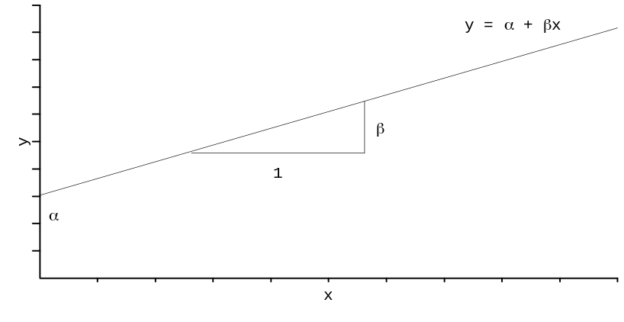

We could draw a line by eye using a transparent ruler but this would be prone to error. A better approach is to use the method of least squares. Using this method we can calculate values for α and β that minimise the vertical distances between the data points and the line. The method is known as least squares because it minimises the sum of the squares of the vertical distances:

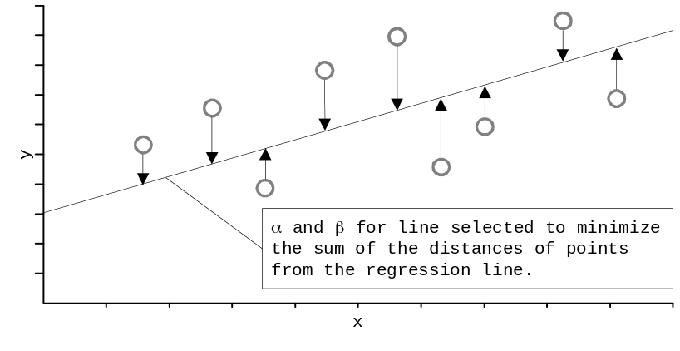

The method of least squares is available in most computer packages (including ANALYSIS) and is often called linear regression or ordinary least squares (OLS) regression. The line found by this method is called the regression line. The regression line estimates the mean value of y for any given value of x. The line always passes through the point defined by the mean value of x and the mean value of y. The slope, β, is usually referred to as the regression coefficient or the β-coefficient.

Before using regression techniques you should be clear which variable is dependant (y) and which is independent (x). The choice does not effect the correlation coefficient but does effect the intercept and regression coefficient.

Linear regression

The REGRESS command in ANALYSIS

You can use the REGRESS command in ANALYSIS to perform linear regression. First clear all selections, and then select all cases for which there are no missing values for WEIGHT and HEIGHT:

select
select weight <> .
select height <> .

Then issue the following command:

regress weight = height

ANALYSIS calculates and displays the Pearson correlation coefficient, 95% confidence limits for the Pearson correlation coefficient, r-squared, the y-intercept (α) and the regression coefficient (β):

Correlation coefficient: r = 0.47
r^2 = 0.22
95% confidence limits: 0.16 < r^2 < 0.28

Source df Sum of Squares Mean Square F-statistic
Regression 1 28800.4259 28800.4259 288.78
Residuals 1028 102523.1469 99.7307
Total 1029 131323.5728

B Coefficients

B 95% confidence Partial
Variable Mean coefficient Lower Upper Std Error F-test
HEIGHT 177.2301 0.7605781 0.672751 0.848405 0.044757 288.7820
Y-Intercept -59.7487821

In this case the Y-Intercept (α) is equal -59.75and the slope (β-coefficient) is equal to 0.76. The equation for the fitted line is:

WEIGHT = -59.75 + (0.76 * HEIGHT)

For each unit increase in HEIGHT, WEIGHT increases by 0.76 kg. The correlation coefficient (r) is equal to 0.47 which suggests that HEIGHT is moderately predictive of WEIGHT. The coefficient of determination is 0.22 suggesting that 22% of the variability in the WEIGHT variable can be explained by the variability in the HEIGHT variable.

There is a formal statistical test that can be used with linear regression. This is the same F Statistic that is used with ANOVA techniques. ANALYSIS calculates the F statistic but does not calculate the associated p-value. The F statistic for this regression is equal to 288.78 which, when compared to the F distribution (at df1 = 1 and df2 = 1029) in a set of statistical tables, is highly significant (p < 0.00001) suggesting that WEIGHT and HEIGHT are associated with each other and that HEIGHT is predictive of WEIGHT.

It is possible to specify more than one independent variable with linear regression. This procedure is called multiple linear regression and is beyond the scope of this book.

What You Should Quote in Reports

If you are using linear regression techniques to analyse your data you should quote r, the F-statistic, degrees of freedom, and p-value:

'We found HEIGHT to be moderately predictive of WEIGHT (r = 0.47, F = 288.78, df=1028, p < 0.00001)'

What the regression line does not explain

Predicted values

The equation for the predicted association between HEIGHT and WEIGHT is:

PREDWT = -59.75 + (0.76 * HEIGHT)

We can define the predicted weight in our sample with the commands:

define predwt ###.##
predwt = -59.75 + 0.76 * height

We can examine the actual and predicted weight for the relevant sample of 1030 records by typing the commands:

describe weight predwt /all

which gives the following output:

Variable Obs Total Mean Variance Std Dev
WEIGHT 1030 77300.000 75.049 127.623 11.297
PREDWT 1030 77193.220 74.945 27.946 5.286

Variable Minimum 25%ile Median 75%ile Maximum Mode
WEIGHT 48.000 67.000 73.000 81.000 118.000 73.000
PREDWT 61.850 71.730 75.530 79.330 89.210 75.530

Note that the mean of WEIGHT and PREDWT are equal, except for rounding error.

We can use the equation to make a prediction of a person’s WEIGHT given their HEIGHT.

select height = 175
describe height weight predwt /all

which gives the following output:

Variable Obs Total Mean Variance Std Dev
HEIGHT 133 23275.000 175.000 0.000 0.000
WEIGHT 133 9787.000 73.586 114.320 10.692
PREDWT 133 9742.250 73.250 0.000 0.000

Variable Minimum 25%ile Median 75%ile Maximum Mode
HEIGHT 175.000 175.000 175.000 175.000 175.000 175.000
WEIGHT 53.000 67.000 71.000 78.000 118.000 71.000
PREDWT 73.250 73.250 73.250 73.250 73.250 73.250

We see that mean WEIGHT is similar to the predicted PREDWT for this group. This is so because the selected HEIGHT is close to the mean HEIGHT of 177.23.
What the regression line does not explain

Residual values

The difference between the values predicted by the regression line and the actual data are called the residuals. It is important that you examine the residuals as it will help you decide how well the linear (straight line) model fits the data and whether you need to apply a transformation to one or both of the variables.

Issue the following commands:

define resid ###.####
resid = weight – (0.76 * height – 59.75)

to calculate the residuals. If we plot the residuals against the original x-variable (HEIGHT):

scatter height resid

we should see a random plot. This would indicate that there is a relatively straightforward association between HEIGHT and WEIGHT and that the straight line summarises much of the structure in the data with the difference between the actual and predicted values being due to random variation.

There should be no structure in a plot of the residuals against the original x-variable. The residual plot should be a random cloud of points. If the residual plot shows some structure (other than randomness) this indicates that the straight line does not summarise the data well and that you may need to apply a transformation to one or both of the variables to make the association more linear.

Practical exercise

Variables and variable names

For a full explanation of variables, their names, and their codes refer to the table on page 10.

Exercise 10 - Correlation and regression

Use the SCATTER command to investigate the association between the various continuous variables in the dataset.

Use the REGRESS command to assess the strength of any associations you find.

Calculate and plot residual values for each of the associations you find.

Solutions to practical exercises

Exercise 1 - Examining a dataset

There are 1043 cases in the SFMHSHIV.REC dataset. The number of cases in a dataset is shown on the first line of the status information at the top of the ANALYSIS screen:

Dataset: A:\SFMHSHIV.REC (1043 records) Free memory: 250K
Criteria: All records selected

The command to SELECT only SMOKERs is:

select smoker = 1

To SELECT only those persons who are not White you should first clear the SELECTion by issuing the SELECT command without specifying a SELECTion criteria:

select

and then issuing the command:

select race <> 1

(Note that the command:

select not (race = 1)

serves the same purpose.)

To SELECT only those persons who are both Hispanic and homosexual/bisexual you should first clear the SELECTion by issuing the SELECT command without specifying a SELECTion criteria:

select

and then issuing the command:

select race = 2 and sexpref = 1

To continue to work with all of the cases in the dataset you should issue the SELECT command without specifying a SELECTion criteria:

select

Solutions to practical exercises

Exercise 2 - Producing charts

Issue the command:

bar race

to produce a BAR chart of RACE groups. The most common race group is 1 (White), with close to 900 people. The other three groups have less than 100 people each.

Issue the command:

pie educ

to produce a PIE chart of EDUCation status. 56.7% had a college degree or any college-level coursework, while 33.0% of the study population had a graduate degree or any graduate-level coursework.

A HISTOGRAM is the most appropriate chart for the AGE variable. The PIE chart is too difficult to read because there are two many ‘slices’ and because the data is ordered (which is difficult to see with a PIE chart). The LINE chart is useful and clear but because LINE charts are often used to show trends over time a LINE chart may be a little confusing for others to read (especially if you include it in a report that also uses LINE charts to show time-series data).

The command to produce a SCATTER plot of the HIVLOAD variable and the CD4 variable is:

scatter hivload cd4

You can specify a regression line be adding ‘/r’ to the SCATTER command:

scatter hivload cd4 /r
Solutions to practical exercises

Exercise 3 - Summarising distributions

The command to examine the distribution of the NPARTC variable is:

freq npartc

which produces the following frequency distribution:

NPARTC | Freq Percent Cum.
-------+-----------------------
0 | 235 22.6% 22.6%
1 | 68 6.5% 29.1%
2 | 213 20.5% 49.6%
3 | 320 30.8% 80.4%
4 | 204 19.6% 100.0%
-------+-----------------------
Total | 1040 100.0%

235 subjects had zero male sexual partners in the previous 2 years. This represents 22.6% of the study population.

The most common NPARTC value is 3 with 320 subjects (30.8% of the study population) having 10-49 male sexual partners in the previous 2 years.

204 cases had an NPARTC value greater than or equal to 50. This represents 19.6% of the study population.

Note that only 1040 cases are shown in the frequency table. This is because there are 3 cases with a missing number of partners.

Solutions to practical exercises

Exercise 3 - Summarising distributions

The command to examine the distribution of the SMOKEAMT variable is:

freq smokeamt

which produces the following output:

SMOKEAMT | Freq Percent Cum.
------------+-----------------------
1 | 50 12.4% 12.4%
2 | 87 21.6% 34.0%
3 | 192 47.6% 81.6%
4 | 74 18.4% 100.0%
------------+-----------------------
Total | 403 100.0%

Total Sum Mean Variance Std Dev Std Err
403 1096 2.720 0.819 0.905 0.045

Minimum 25%ile Median 75%ile Maximum Mode
1.000 2.000 3.000 3.000 4.000 3.000

Student's "t", testing whether mean differs from zero.
T statistic = 60.321, df = 402 p-value = -0.00000

12.4% of the study population smoked less than ½ pack per day (coded as SMOKEAMT = 1).

21.6% of the study population smoked ½ to one pack per day (coded as SMOKEAMT = 2).

18.4% of the study population smoked 2 or more packs per day (coded as SMOKEAMT = 4).

It is not valid to use the sum, mean, and standard deviation to summarise the distribution of the SMOKEAMT variable because it is a categorical variable and these summary measures can only be applied usefully to continuous variables.

You can see a visual representation of a frequency table using the BAR and PIE commands:

bar smokeamt
pie smokeamt

Solutions to practical exercises

Exercise 4 - Summarising distributions

The commands to produce the seven figure summaries for the AGE, NPARTNER, HEIGHT, WEIGHT, and CD4 variables are:

describe age npartner height weight cd4 /all

Your completed table should look like this:

 | AGE | NPARTNER | HEIGHT | WEIGHT | CD4
number of cases | 1042 | 1040 | 1035 | 1031 | 978
mode | 29.000 | 0.000 | 178.000 | 73.000 | 778.000
median | 34.000 | 10.000 | 178.000 | 73.000 | 873.000
mean | 34.773 | 37.476 | 177.206 | 75.088 | 919.299
minimum | 22.000 | 0.000 | 160.000 | 48.000 | 47.000
maximum | 55.000 | 998.000 | 196.000 | 118.000 | 7107.000
standard deviation | 6.724 | 95.267 | 6.949 | 11.363 | 438.520

Visual representations of the distribution of these variables can be produced using the HISTOGRAM command:

histogram age
histogram height
histogram weight

The mode, median, mean, minimum, and maximum of the AGE variable are marked on this graph:

Mode Median Mean
Minimum
Maximum
Solutions to practical exercises

Exercise 5 - Recoding variables and two-by-two tables

The first step in this exercise is to examine the distribution of the CD4 variable:

describe cd4 /all

which produces the following output:

Variable Obs Total Mean Variance Std Dev
CD4 978 899074.000 919.299 192300.046 438.520

Variable Minimum 25%ile Median 75%ile Maximum Mode
CD4 47.000 631.000 873.000 1137.000 7107.000 778.000

And then use the lower quartile as a cut-point for a newly defined variable:

define cd4group <AAAAAAA>
recode cd4 to cd4group lo-631="1LOW" 632-hi="2NORMAL"

You should always check the result of any RECODE command using the BROWSE or LIST commands:

browse cd4 cd4group

And then to use the TABLES command to investigate the association between HIVSTAT and your new variable:

set percents = on
tables hivstat cd4group

which produces the following output:

CD4GROUP
HIVSTAT |1LOW 2NORMAL | Total
-----------+---------------+------
1 | 195 193 | 388
> 50.3% 49.7% > 39.7%
| 79.3% 26.4% |
2 | 51 539 | 590
> 8.6% 91.4% > 60.3%
| 20.7% 73.6% |
-----------+---------------+------
Total | 246 732 | 978
| 25.2% 74.8% |

Single Table Analysis

RISK RATIO(RR)(Outcome:CD4GROUP=1LOW; Exposure:HIVSTAT=1) 5.81
95% confidence limits for RR 4.39 < RR < 7.70

Ignore risk ratio if case control study

Chi-Squares P-values
----------- --------

Uncorrected: 215.30 0.00000000 <---
Mantel-Haenszel: 215.08 0.00000000 <---
Yates corrected: 213.10 0.00000000 <---

Showing that those in the HIV-infected group (HIVSTAT = 1) group are more likely to have low CD4 counts (RR = 5.81, 95% C.I. 4.39 – 7.70, Yates chi-square = 213.10, p < 0.000001). You can also use the TABLES command to investigate the association between SEXPREF, SMOKER, and POPPERS and your new variable:

tables sexpref cd4group
tables smoker cd4group
tables poppers cd4group

Solutions to practical exercises

Exercise 6 - Recoding, subsets, and two-by-two tables

Use the MEANS command to find the quartiles of the distribution of the HIVLOAD variable (as was done in the previous exercise):

describe hivload /all

and then use the DEFINE and RECODE commands to create the variables holding the grouped data:

define hivgroup <AAAAA>
recode hivload to hivgroup lo-87096="2LOW" 87097-hi="1HIGH"

and remember to use the BROWSE or LIST command to check the results of the RECODE commands:

browse hivload hivgroup

Then use the TABLES command to investigate the association between RACE and your new variable:

tables race hivgroup

Showing that there is no difference in HIV load between Hispanics and Blacks. (RR = 2.70, 95% C.I. 0.62 – 11.72, Yates chi-squares = 1.06, p = 0.304). Note that the relative risk indicates a 2.7-fold higher risk of high HIV load for Hispanics, but the confidence interval includes 1. This is likely due to the small number of Blacks and Hispanics who are HIV-infected. Therefore, the data do not support the hypothesis that Blacks are at greater risk of high HIV load relative to Hispanics.

Solutions to practical exercises

Exercise 7 - Analysis of variance (ANOVA)

The commands needed to complete this exercise are:

select
select race <> 4
means weight race /n
means age race /n

The White, Hispanic, and Black race groups had different mean weights (White mean = 75.244, Hispanic mean = 72.769, Black mean = 79.176, F = 4.309, df = (2,987), P = 0.014).

The White, Hispanic, and Black race groups did not have differenct mean ages (White mean = 34.876, Hispanic mean = 33.500, Black mean = 35.500, F = 1.295, df = (2,998), P = 0.274).

Note that these finding may not be valid as some of the ANOVA assumptions may be violated (see pages 62-63 and Exercise 8 on page 64).

Solutions to practical exercises

Exercise 8 - Testing the ANOVA assumptions

The commands needed to complete this exercise are:

select
means weight race /n
means age race /n

By comparison of means, median and modes, as well as comparison of variances or standard deviations using Bartlett’s test, both variables meet the ANOVA assumptions.

To examine the distributions of these variables they may first be grouped:

define wtgroup <AAAAAAAAAA>
if weight <> . then recode weight to wtgroup by 5

define agegroup <AAAAAAAA>
if agegroup <> . then recode age to agegroup by 5

before issuing the LINE commands to examine the underlying distributions:

line wtgroup race
line agegroup race

Examination of these charts shows that the both variables are approximately normally distributed. This means that it is valid to use ANOVA techniques with the WEIGHT and AGE variables.
Solutions to practical exercises

Exercise 9 - Doing it!

You’re on your own for this exercise. The descriptive and analytical techniques and the ANALYSIS commands necessary for this exercise (and the analysis of the data arising from the San Francisco Men’s Health Study) have all been introduced and rehearsed in the previous exercises. Good luck . . .
Solutions to practical exercises

Exercise 10 - Correlation and regression

You will have to issue many SCATTER and REGRESS commands to investigate each possible pair of variables to complete this exercise:

SCATTER commands | REGRESS commands
scatter npartner height /r | regress height npartner
scatter npartner weight /r | regress weight npartner
scatter npartner cd4 /r | regress cd4 npartner
scatter npartner hivload /r | regress hivload npartner
scatter height weight /r | regress weight height
scatter height cd4 /r | regress cd4 height
Scatter height hivload /r | regress hivload height
scatter weight cd4 /r | regress cd4 weight
scatter weight hivload /r | regress hivload weight
scatter cd4 hivload /r | regress hivload cd4

In this exercise we have ignored considerations about which variable is the independent or explanatory variable and which variable is the dependent or response variable (see page 81). An association exists only between HEIGHT and WEIGHT. See pages 81-87 for the results of this regression and residual values.

y-variable | x-variable | r | 95% C.I.
WEIGHT | HEIGHT | 0.47 | 0.40 - 0.53

The command:

regress weight height

produces the following output:

ß 95% confidence Partial
B 95% confidence Partial
Variable Mean coefficient Lower Upper Std Error F-test
HEIGHT 177.2301 0.7605781 0.672751 0.848405 0.044757 288.7820
Y-Intercept -59.7487821

Variable Mean coefficient Lower Upper Std Error F-test
GHQ 7.7947 0.2762311 0.148804 0.403658 0.065014 18.0524
Y-Intercept 16.5554701

Residuals may be calculated and displayed using the following commands:

define wtresid ##.####
wtresid = weight - (-59.75 + (0.76 * HEIGHT))
scatter height wtresid

The scatter plot is a random cloud of points indicating that the straight line:

scatter height weight /r

summarises the data well and that no transformation need be applied to either variable.

Statistical tables

Statistical tables

The following pages show partial statistical tables for the chi-square distribution, the sum of ranks in the smallest group in the Wilcoxon rank sum test (W), and the F-distributions, with examples of how to use them.

ANALYSIS automatically calculates p-values for most procedures but does not do so for the F under linear regression. If you intend to use ANALYSIS to perform linear regression you will have to refer to the table on page 103 to obtain a p-value. If you intend to use ANALYSIS to perform multiple linear regression you will need to purchase a set of statistical tables. A suitable set of tables is:

Neave HR, Elementary Statistical Tables, Routledge, 1981

Statistical tables

Percentage points of the chi-square distribution

The following table compares use of MARIJUANa to HIVSTATus:

HIVSTAT
MARIJUAN | 1 2 | Total
-----------+---------------+------
1 | 368 521 | 889
2 | 40 104 | 144
-----------+---------------+------
Total | 408 625 | 1033

and yields a Pearson's chi-square statistic of 8.15. The degrees of freedom for this table are:

(rows - 1) * (columns - 1) = (2 - 1) * (2 - 1) = 1

From the table below we can see that for a chi-square of 9.62 on 1 degree of freedom the p-value is between p = 0.001 and p = 0.005:

 | p-value
d.f. | 0.05 | 0.01 | 0.005 | 0.001
1 | 3.84 | 6.63 | 7.88 | 10.83
2 | 5.99 | 9.21 | 10.60 | 13.82
3 | 7.81 | 11.34 | 12.84 | 16.27
4 | 9.49 | 13.28 | 14.86 | 18.47
5 | 11.07 | 15.09 | 16.75 | 20.52
6 | 12.59 | 16.81 | 18.55 | 22.46
7 | 14.07 | 18.48 | 20.28 | 24.32
8 | 15.51 | 20.09 | 21.96 | 26.13
9 | 16.92 | 21.67 | 23.59 | 27.88
10 | 18.31 | 23.21 | 25.19 | 29.59
11 | 19.68 | 24.73 | 26.76 | 31.26
12 | 21.03 | 26.22 | 28.30 | 32.91
13 | 22.36 | 27.69 | 29.82 | 34.53
14 | 23.68 | 29.14 | 31.32 | 36.12
15 | 25.00 | 30.58 | 32.80 | 37.70
16 | 26.30 | 32.00 | 34.27 | 39.25
17 | 27.59 | 33.41 | 35.72 | 40.79
18 | 28.87 | 34.81 | 37.16 | 42.31
19 | 30.14 | 36.19 | 38.58 | 43.82
20 | 31.41 | 37.57 | 40.00 | 45.32

This would be reported as:

'We found an association between use of marijuana and being HIV-infected (chi-square = 9.62, p < 0.005).'

Note that only a partial table is shown here as ANALYSIS calculates and reports a p-value automatically.

Statistical tables

Critical ranges for the Wilcoxon Rank Sum Test

The Worked Example of the Wilcoxon Rank-Sum Test shown on page 72 yielded a W-statistic of 32 with sample sizes for the two groups of five and six. The table below shows 32 to be within the critical range of 18 to 42 at p = 0.05 for group sizes of five and six:

 | p-value
n1, n2 | 0.05 | 0.01 | 0.001
5, 5 | 17 to 38 | 15 to 40
5, 6 | 18 to 42 | 16 to 44
5, 7 | 20 to 45 | 17 to 48
5, 8 | 21 to 49 | 17 to 53
5, 9 | 22 to 53 | 18 to 57 | 15 to 60
5, 10 | 23 to 57 | 19 to 61 | 15 to 65
5, 11 | 24 to 61 | 20 to 65 | 16 to 69
5, 12 | 26 to 64 | 21 to 69 | 16 to 74
5, 13 | 27 to 68 | 22 to 73 | 17 to 78
5, 14 | 28 to 72 | 22 to 78 | 17 to 83
5, 15 | 29 to 76 | 23 to 82 | 18 to 87
5, 16 | 31 to 79 | 24 to 86 | 18 to 92
5, 17 | 32 to 83 | 25 to 90 | 19 to 96
5, 18 | 33 to 87 | 26 to 94 | 19 to 101
5, 19 | 34 to 91 | 27 to 98 | 20 to 105
5, 20 | 35 to 95 | 28 to 102 | 20 to 110
n1, n2 = sample sizes of two groups
Significant if sum of ranks (W) in smallest
group is on boundary or outside of range

This would be reported as:

'We found no association between White race and height (Wilcoxon Rank-Sum Test,W = 32, p > 0.05)'.

Note that only a partial table is shown here as ANALYSIS calculates and reports a p-value automatically.

Statistical tables

Percentage points of the F distribution

The following output:

Source df Sum of Squares Mean Square F-statistic
Regression 1 28800.4259 28800.4259 288.78
Residuals 1028 102523.1469 99.7307
Total 1029 131323.5728

B Coefficients

B 95% confidence Partial
Variable Mean coefficient Lower Upper Std Error F-test
HEIGHT 177.2301 0.7605781 0.672751 0.848405 0.044757 288.7820
Y-Intercept -59.7487821

was produced by the command:

regress weight = height

Degrees of freedom df1 is the number of independent variables (1) and the degrees of freedom df2 is the number of cases minus the number of independent variables minus one (1028).

From the table below we can see that the p-value for F of 288.78 on 1 and 1028 degrees of freedom (we have to look at the values for df2 = ∞) is p < 0.001:

df2 | p -value | df1 = 1 |  | df2 | p - value | df1 = 1
10 | 0.05 | 4.96 |  | 25 | 0.05 | 4.24
 | 0.01 | 10.04 |  |  | 0.01 | 7.77
 | 0.001 | 21.04 |  |  | 0.001 | 13.88
12 | 0.05 | 4.75 |  | 30 | 0.05 | 4.17
 | 0.01 | 9.33 |  |  | 0.01 | 7.56
 | 0.001 | 18.64 |  |  | 0.001 | 13.29
14 | 0.05 | 4.60 |  | 40 | 0.05 | 4.08
 | 0.01 | 8.86 |  |  | 0.01 | 7.31
 | 0.001 | 17.14 |  |  | 0.001 | 12.61
16 | 0.05 | 4.49 |  | 60 | 0.05 | 4.00
 | 0.01 | 8.53 |  |  | 0.01 | 7.08
 | 0.001 | 16.12 |  |  | 0.001 | 11.97
18 | 0.05 | 4.41 |  | 120 | 0.05 | 3.92
 | 0.01 | 8.29 |  |  | 0.01 | 6.85
 | 0.001 | 15.38 |  |  | 0.001 | 11.38
20 | 0.05 | 4.35 |  | ∞ | 0.05 | 3.84
 | 0.01 | 8.10 |  |  | 0.01 | 6.63
 | 0.001 | 14.82 |  |  | 0.001 | 10.83

This would be reported as:

'We found an association between the height and weight (F = 288.78, df = 1028 p < 0.001)'.

It may also be appropriate to quote the Pearson correlation coefficient in this situation.

Note that you do not need to use this table to assess the significance of F with the MEANS command as ANALYSIS calculates a p-value automatically.

